**1 ACKNOWLEDGEMENT I**

**2 ABSTRACT II**

**3 TABLE OF CONTENTS III**

**4 LIST OF FIGURES IV**

**CONTENTS**

**1. Introduction 4**

1.1 Background 5

1.2 Literature survey 5

1.3 Motivation 10

1.4 Problem statement 11

1.5 Aim and objectives 11

1.6 Scope 12

1.7 Challenges 12

1.8 Organization of thesis 12

**2. Overview 15**

**3. Requirement specification 16**

3.1 Hardware requirement 16

3.2 Software requirement 16

**4. Detailed design 17**

4.1 Architectural design-level 0 DFD 19

4.2 Level 1 DFD 20

4.3 Behavioural diagram 21

**5. Implementation 22**

5.1 Programming Languages and Algorithms used 22

5.2 Implementation of Modules of Project 23

**6. Testing 32**

6.1 Test Environment Description 32

6.2 Test Cases 33

6.3 Testing the Neural Network Model 36

**7. Experimental results 37**

**8. Conclusion 43**

**9. References 44**

**LIST OF FIGURES AND TABLES**

**Title Page No**

1.1 Bedsores pressure points in the human body 5

4.1 Process Diagram 17

4.2 Architecture Diagram 17

4.3 Architecture Design 19

4.4 Level 1 DFD 20

4.5 Behavioural Design 21

5.1 Working of FSR 25

5.2 DHT11 Sensor 26

5.3 Arduino Uno 28

5.4 Neural Network Architecture 29

5.5 Bed Design 29

5.6 a) Moisture sensor placed on skin 30

b) The four pressure sensors placed on a seat

5.3 The circuit, seen on a bread board, connected to an Arduino Uno 31

and the various sensors

5.4 a) Pressure sensors distributed across a seat 31

b) Person sitting on the seat as the circuit reads the values from the sensors

6.1 Connection to DB dropping frequently 35

6.2 Fixed using handlers 36

7.1 Login Screen 37

7.2 Dashboard 38

7.3 Sensor Monitor 39

7.4 Historical Data 39

7.5 Patient Information 40

7.6 Add Patient Information 40

7.7 Sensor Data 41

Table 7.1 Accuracy Indices 42

**Chapter 1**

**Introduction**

Older people, whether staying at home, in hospitals or in retirement homes, incur the risk of health symptoms and problems. Due to the advent of COVID-19, the number of cases where the patient is prescribed bed rest is soaring. In many cases, some form of monitoring is helpful to aid the healthcare personnel in preventing the degradation of the patient’s health status. Decubitus ulcers (DU), also called bedsores or pressure ulcers, are wounds that develop when the skin undergoes constant pressure for a prolonged duration. Due to bony prominence, the common sites for DU include heels, shoulder blades, elbow, and coccyx/sacrum (gluteal). They are a common injury that mainly plagues elders and frail people, and is a major cause of concern in medical institutions. Current screening and prevention techniques for assessing risk for decubitus ulcer formation and repositioning patients every 1-3 hours are labour-intensive and can be subjective.

According to statistics from the Centres for Disease Control (CDC), DUs affect 2.5 million people yearly, and that also includes 1.6 lakh patients in nursing homes. There is a huge amount of money spent (~$11.6 Billion) on the treatment of DUs every year in the United States alone.

We have proposed a system using low-cost, disposable wireless, and unobtrusive fabric-based pressure sensors and hygrometer (to measure moisture levels on the skin) to continuously monitor the tissue status in at-risk areas already developed to detect the pressure and make the necessary adjustments to the bed to prevent the same.

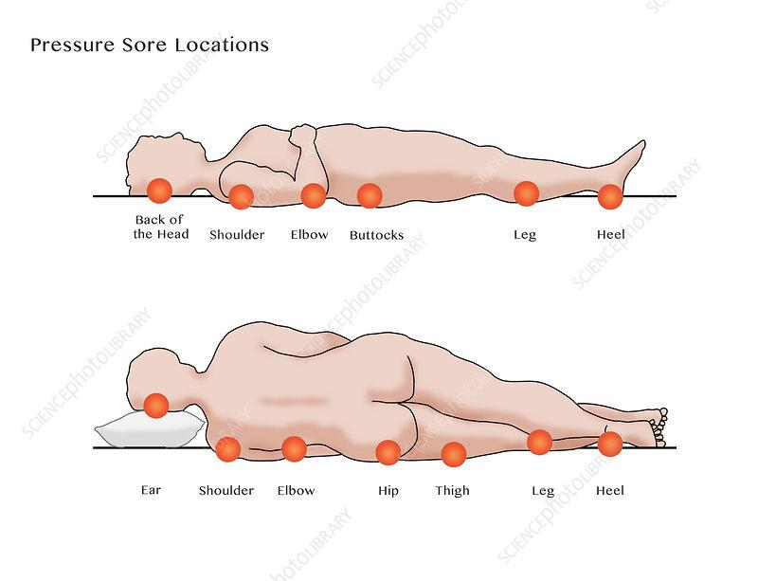

Fig 1.1: Bedsores pressure points in the human body

**1.1 Background**

Decubitus ulcers affect many bedridden patients across the world. Each year, more than 2.5 million people in the United States develop pressure ulcers. It develops in patients over time and can be a silent killer if not prevented. Bedridden patients are usually already suffering from an ailment. Bed sores can be an impediment, if not a retardation factor, in their recovery.

**1.2 Literature Survey**

Multiple decubitus ulcer risk assessment tools are used worldwide with the most popular being the Braden, Norton, and Waterlow scales. Braden scale[[1]](https://docs.google.com/document/d/1Dk7tNwMs0lxxAbOMOYt_RjeRtqrPWA51/edit#heading=h.maz4h9h9mlgf) is the most widely used scale and is used to store various parameters in six subscales, concerning the physical status of the subject, like sensory perception, skin moisture, activity, mobility, friction and shear, and nutritional status. After evaluation of all the parameters, a score is arrived at, which indicates how susceptible the subject is to a DU. While quantitative, scoring can be subjective and studies have shown high variability in scoring among clinicians. Based on the score, the subject is monitored by the caregiver.

There are various wearable devices to help in detecting (lack of) ambulation, and if there is none for a long period, the caretakers are alerted and action is taken[9][7]. Other publications mention the use of image classification[4][10] to detect bedsores using logistic regression, KNN clustering, and other deep learning techniques. IoT techniques are also used for real-time monitoring of the subjects using various sensors[2].

The other set of publications mention the use of sensors such as FSR (Force Sensing Resistor), pulse oximeter (SPO2), pulse and heart rate sensor, humidity, and temperature sensors to analyze the physical conditions, and ambulation and predict the formation of a DU.

The publications that deal with the prevention of DUs, use mattresses[6][8][11] in various ways, like, increasing area of contact, decreasing pressure, using different kinds of materials like sheepskin[3], dialysis bags[5], CME (Combustion Modified Ether)[3] foam mattresses are suitable for those up to the medium risk of developing a pressure ulcer. Visco mattresses are suitable up to high risk or very high risk etc., to predict as well as prevent the formation of a DU.

Assessment is typically performed during admission, discharge, and changes in the patient’s condition. Prevention and management of decubitus ulcers involve patient repositioning and pressure redistribution devices. Patient repositioning typically occurs every 1-2 hours to prevent tissue ischemia, though the determination of timing is arbitrary. Patients at high risk of or have already acquired a decubitus ulcer are managed with special support surfaces such as foam or gel cushions that relieve or redistribute pressure.

[**N Bergstrom**](https://pubmed.ncbi.nlm.nih.gov/?term=Bergstrom+N&cauthor_id=3299278)**,** [**B J Braden**](https://pubmed.ncbi.nlm.nih.gov/?term=Braden+BJ&cauthor_id=3299278)**,** [**A Laguzza**](https://pubmed.ncbi.nlm.nih.gov/?term=Laguzza+A&cauthor_id=3299278)**,** [**V Holman**](https://pubmed.ncbi.nlm.nih.gov/?term=Holman+V&cauthor_id=3299278) **[1]** suggested using the Braden Scale for Predicting Pressure Sore Risk was developed to foster early identification of patients at risk for forming pressure sores. The scale is composed of six subscales that reflect sensory perception, skin moisture, activity, mobility, friction and shear, and nutritional status. Content and construct validity were established by expert opinion and empirical testing. Three studies of reliability are reported here, using raters who varied in level of educational preparation and geographic region. Two prospective studies of predictive validity were completed to determine the scale's sensitivity and specificity. Reliability ranged from r = .83 to r = .94 for nurses' aides and licensed practical nurses; when used by registered nurses, the reliability increased to r = .99. Predictive validity was calculated for each cut-off point of the scale. Using a cut-off point of 16, sensitivity was 100% in both studies. Specificity ranged from 64% to 90%. This instrument has highly satisfactory reliability when used by RNs, and greater sensitivity and specificity than instruments previously reported.

**Sam Mansfield, Eric Vin, Katia Obraczka [2]** introduce PIMAP, an IoT-based system for continuous, real-time patient monitoring that operates in a fully autonomous fashion, i.e. without the need for human intervention. PIMAP is the first open system that integrates the basic patient monitoring workflow including sensed data collection, storage, analysis, and real-time visualization. PIMAP's open design allows it to easily integrate a variety of sensors (custom and off-the-shelf), analytics, and visualization. Other novel features of PIMAP include its deployment flexibility, i.e., its ability to be deployed in different configurations depending on the specific application needs, setting, and resources, as well as PIMAP's self-profiling and self-tuning capabilities. While PIMAP can be applied to various patient monitoring applications and settings, in this paper we focus on the unsolved problem of preventing pressure ulcers, or pressure injuries. It is described how PIMAP's design addresses autonomous, continuous, realtime operation to sense, store, analyze, and visualize patient data from a variety of off-the-shelf as well as custom sensors. The current PIMAP prototype as well as different PIMAP configuration scenarios are presented, e.g. cloud-based or edge-based deployment options. We also evaluate PIMAP's performance under different workloads and demonstrate its use collecting wearable pressure sensor data in real-world scenarios from patients with high risk of forming pressure injuries.

**Monica Puri Sikka, Samridhi Garg [3]** aims to summarize researches conducted related to functional textiles for prevention of pressure ulcers and critical analysis of the outcomes to pave path for the future research in this area for benefit of the patients. Pressure ulcers, also known as bed sores, pressure sores and decubitus ulcers, are localized areas of tissue damage that develop due to pressure usually over a bony prominence. A standard hospital mattress has an interface pressure of 100 mmHg which can result in pressure ulcers unless repositioning occurs at regular intervals. Moisture accumulation on the skin is an important physical factor predisposing a patient to the occurrence of pressure ulcers and tissue breakdown. The disability leads to several requirements of functional clothing and textile products. The textiles play a variety of roles in this concern, from simply having good aesthetic appearance to preventing life threatening risks. An ideal support surface prevents pressure ulcers by providing pressure redistribution and maintaining a healthy skin microenvironment. The use of the textiles for the care of elderly disabled and bedridden persons can play an important role, as their quality of life can be improved by making use of functional and good-looking textiles.

**Bilge Yilmaz; Ercan Atagün; Fadime ÖĞÜLMÜŞ Demırcan; İbrahim Yücedağ [4]** aim to prevent wound formation or to make a positive contribution to the treatment processes by using machine learning techniques in image analysis for the classification of pressure ulcers. In this study, 142 wound images were analyzed by Logistic Regression and Artificial Neural Networks methods. Features such as wound color and size in these images were separated by image processing and the stage of the wound was determined from the images. The 6 stages of pressure ulcers are referenced for classification.

**Therdpong Daengsi; Bundit Muttisan; Pongpisit Wuttidittachotti; Patsita Sirawongphatsara [5]** presents the development of an air mattress to prevent pressure ulcers in patients who have limited movement. The major part of this mattress is a set of re-used dialysis bags that are a kind of waste from hospitals. This mattress prototype has been developed using Arduino Nano boards, force sensitive resistor (FSR) sensors and diaphragm air compressors. After completion, the first version of the air mattress prototype was evaluated by experienced nursing workers as acceptable with a score of 3.24±0.75, based on 5-point scale, which means further improvements for the next version are required.

**Malindu Ehelagastenna; Ishan Sumanasekara; Hishan Wickramasinghe; Indrajith D. Nissan [6]** discusses the development of an alternating pressure overlay designed with miniaturized air cells for the treatment of pressure ulcers. Pressure ulcers can be identified as a skin deformity due to application of prolonged pressure on the skin causing improper blood circulation. The alternating behaviour of the air cells aid in pressure relieving, thus provide better blood circulation to carry vital nutrients to the tissues while reducing formation of pressure ulceration. The proposed design miniaturizes the air cell sizes and establish an optimum air cell size to provide high-resolution pressure therapy in comparison to existing designs. This optimum air cell size, geometry along with its 3D deformation profiles were analysed using finite element method. The findings of the numerical simulations concluded that individual cell design should contain a minimum cell membrane thickness of 5mm and an overlay height of 185mm to withstand a maximum pressure of 60mmHg. Optimum pressure pattern of the alternating pressure therapy was selected as 1-in-4 pressure pattern, where the pressure overlay was divided into five pressure zones to actuate and map the interface pressures required. The control system was designed to provide required alternating pressure for patients by detecting the high pressure zones.

**Eun-Bin Park; Jin-Chul Heo; Chanil Kim; Beomjoon Kim; Kwangyeol Yoon [7]** examined the effects of the pressure ulcer-induced regions based on impedance measurements and skin electrical signals, and its treatment efficacy was verified using photobiomodulation therapy. The light used in this therapy was a light emitting diode light (660 nm), and it was verified to enhance antioxidant capacity in the enzyme-based antioxidation process. An examination of the angiogenesis efficacy based on wound healing activity and tube formation activation at the cell level confirmed that photobiomodulation therapy accelerated wound healing and angiogenesis. When the treatment effect of the therapy was evaluated with a rat animal model of pressure ulcer, the region affected by the pressure ulcer and the infiltration of inflammatory cells were significantly reduced by photobiomodulation therapy. The diagnosis using skin impedance measurement showed differences in the region affected by the pressure ulcer. The results of this study confirmed the diagnosis based on the impedance and treatment efficacy of photobiomodulation therapy and the treatment of pressure ulcer. The use of photobiomodulation therapy in conjunction with the existing treatment methods is expected to improve the efficiency of the pressure ulcer treatment.

**Jan Kottner , Janet Cuddigan , Keryln Carville [10]** provide a brief theoretical background about pressure ulcer/injury classification, to explain the approach the Guideline Governance Group has taken during the 2019 update of the International Guideline for 'Prevention and Treatment of Pressure Ulcers/Injuries' and to share views on how to best implement pressure ulcer/injury classification. First formal pressure ulcer/injury classifications were introduced in the 1950s and today various pressure ulcer/injury classification systems are used worldwide. Dissimilarities between commonly used classification systems may be considered a limitation that impedes clinical and scientific communication. However, the conceptual meaning of pressure ulcer/injury categories described within the various classification systems is comparable and the current evidence does not indicate that one classification is superior to another. Therefore, the Guideline Governance Group created a crosswalk of the major pressure ulcer/injury classifications in common use across different geographic regions. Clinicians are encouraged to use the classification system adopted by their healthcare setting in the most consistent way. The validity of pressure ulcer/injury classification is closely linked to its intended purpose. Studying measurement properties of pressure ulcer/injury classification systems must follow state-of-the-art methods. Structured educational interventions are helpful for improving diagnostic accuracy and reducing misclassification of pressure ulcers/injuries. Implementation of innovative skin and soft tissue assessments and revised pressure ulcer/injury classifications are only worth implementing, when the diagnostic information improves clinical care.

**1.3 Motivation**

The motivation that led us to develop a solution to detect and prevent bedsores is the amount of damage it can cause to a bedridden patient/immobile person. It can penetrate the bone, and cause irreversible damage and infection. This can be an impediment or a factor of retardation in the recovery of patients. A lot of attention that bedsores demand can instead be put into healing the actual ailment of the subject.

**1.4 Problem Statement**

Decubitus Ulcers are dangerous and can have severe consequences, leading to long-term hospitalization. At more severe stages, bedsores become very painful, and the patient is at risk of surgery and even death. The goal of this project is to predict and prevent the formation of bedsores without human intervention. Prevention techniques in hospitals and retirement homes today are still traditional, where the healthcare personnel/caretaker spends a considerable amount of time regularly checking the status of their patients and their changes in body position and other body parameters. In the proposed system, data is gathered from an array of ambient pressure sensors to evaluate the vulnerable areas depending on the total time of impact and other factors.

**1.5 Aim and Objective**

This project aims to be able to detect and prevent the occurrence of bedsores. This is proposed to be done by:

* Developing circuitry with the necessary sensors, to detect constant symptoms that point to the possibility of occurrence of bedsores
* Developing an interface as a front end, to examine the likelihood or risk that the patient is, of developing a bedsore
* A set of API endpoints for:
  + The circuitry to upload the values to the database
  + The front end retrieves the values from the database
* A real-time analysis engine that can input the values from the circuitry and analyse the data, to infer the likelihood of developing bedsore, using machine learning and artificial intelligence techniques

**1.6 Scope**

The demographic that this project may help are persons with less mobility in their day-to-day activities, with an area of their body where most of the body weight is concentrated.

**1.7 Challenges**

Body pressure dispersion mattresses are useful tools for preventing pressure ulcers. Pressure-reducing mattresses redistribute a patient's weight to relieve pressure points, but critical factors such as physical conditions and moisture are usually ignored. Another important factor to consider is the comfort of the patient, which is often overlooked. A suitable fabric/mattress that minimizes the shearing effect and also provides good aeration and ventilation to the subjects is also disregarded.

**1.8 Organization of the thesis**

The presentation of a thesis and its significant contents plays the vital role in knowledge transfer and optimal object discussion with better understanding and knowledge flow. Taking into consideration of this requirement here in this thesis the overall thesis has been classified into nine chapters where each chapter discusses its individual objectives. The outline is as follows:

**Chapter-1 Introduction**

This chapter provides introduction of the research work and in this section of the presented manuscript, the key components such as research background, research objectives, motivations, proposed system, problem formulation and research significance for the developed hand gesture detection scheme have been discussed. The prime objective of this chapter is to facilitate an introduction of the proposed research.

**Chapter-2 Overview**

In this chapter a brief overview of the overall system has been specified.

**Chapter-3 Requirement Specification**

In this chapter the requirement specifications and associated hardware configuration has been discussed.

**Chapter-4 Detailed Design**

In this chapter the detailed design of the system has been specified. This chapter consists of the various Data Flow Diagrams (DFDs), architectural diagram, process flow diagram etc and the details about these diagrams have been specified.

**Chapter-5 Implementation**

In this chapter the developed system implementation and realization of the research model has been presented. The associated Pseudo codes developed hand gesture recognition and HCI oriented command generation have been discussed in this chapter.

**Chapter-6 Testing**

Considering the significance of system testing for any system development and its robustness validation, in this chapter the testing of developed system model has been provided. Testing

accomplished for various levels such as unit model test, integrated test and complete model test etc have been discussed in this section.

**Chapter-8 Experimental Results**

In this chapter the results obtained for the proposed system have been given. The system implementation and its results realization for varied gesture patterns data has been presented in this part of manuscript. The system analysis for its robustness with respect to varied gesture position, orientation and sign language have been obtained and discussed in this chapter. The robustness and effectiveness of the proposed system can be obtained from this chapter.

**Chapter-9 Conclusion**

In this section the conclusion derived for the complete system has been provided. The system and its outcomes with probable enhancement have been mentioned in this chapter. This chapter has been followed by References used in this research work.

**Chapter 2**

**Overview**

The solution that we propose, to solve the issue of bedsores can be divided into two parts:

* Prediction
* Prevention

The prediction of bedsores involves continuously monitoring various physical parameters: pressure, ambient humidity, skin temperature, skin moisture, etc. Prevention involves redistributing pressure around the mattress to delocalized pressure.

The physical parameters that we are measuring are:

* Body pressure, measured through pressure sensors distributed across the mattress (roughly 4 sensors per mattress)
* Ambient temperature and ambient humidity
* Body temperature and skin moisture

These parameters are the features that affect the formation of bedsores. When any of these parameters are screened to be consistently high, we can consider the subject to be at risk of developing bedsore.

**Chapter 3**

**Requirement Specification**

The system requirements are as follows:

**3.1 Hardware Requirements**

* Arduino Uno R3
* SCX30ANC pressure sensor
* SEN-13322 moisture sensor
* NodeMCU ESP8266
* NW miniature air pump 5V-6VDC 400KPA 370

**3.2 Software Requirements**

* Notification Service
* Arduino IDE
* Browser
* Python 3.7
* Windows OS 10 and above
* NodeJS 14.7 and above

**Chapter 4**

**Detailed Design**

The process of the system is as shown in the diagram below:

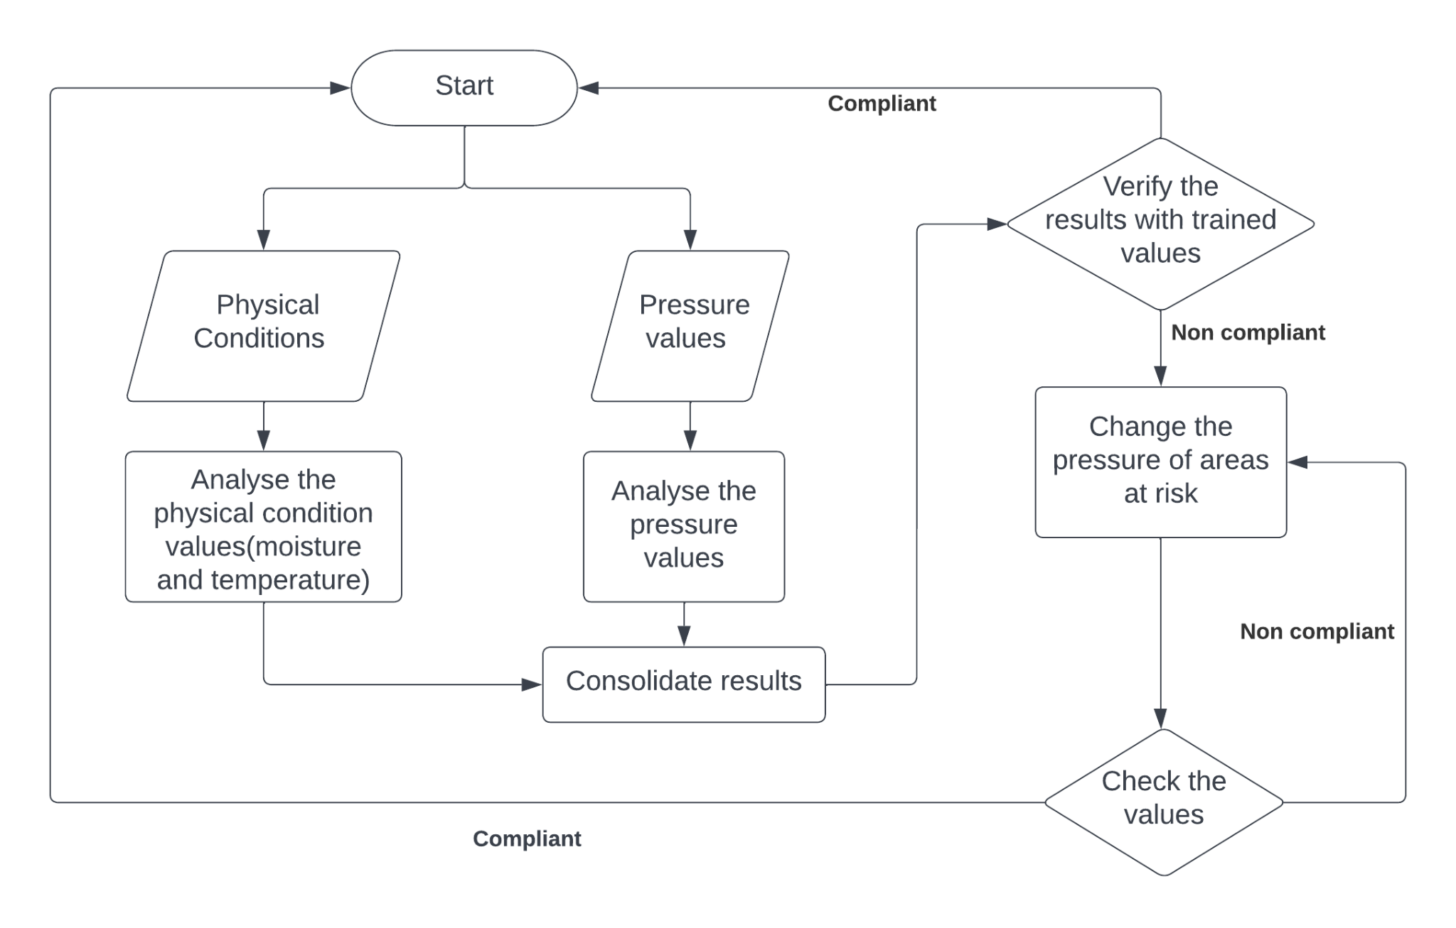

Fig 4.1 Process Diagram

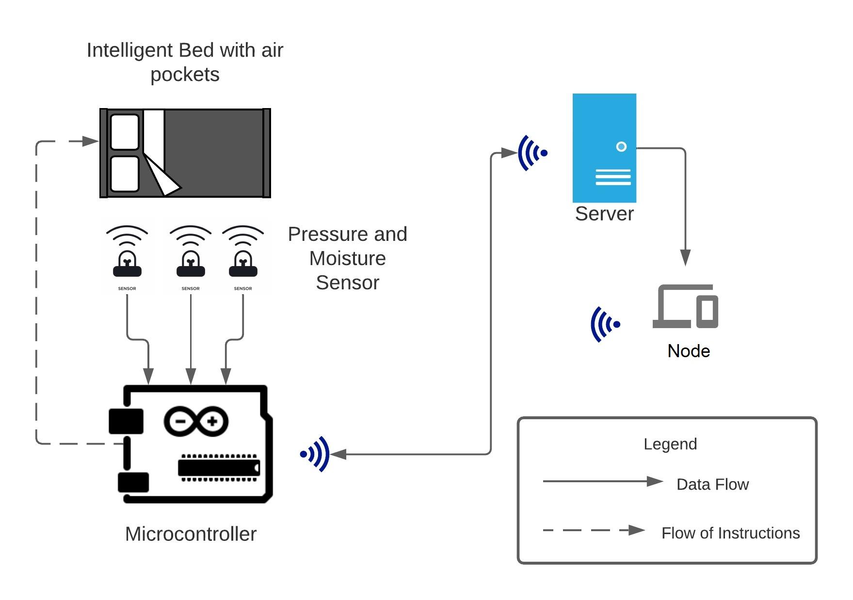

Fig 4.2 Architecture Diagram

The process is as described:

1. The patient generates data pertaining to their physical conditions, ie., the moisture and temperature, and also pressure values.
2. These values are consolidated and analyzed
3. The results of the analysis are verified with baseline values and are checked if they are compliant or not
4. If compliant, then we re-run the loop
5. If the values do not comply with the baseline values, then the pressure in the at-risk areas is changed. Post changing, the values are checked again immediately for compliance
6. If compliant, then we re-run the loop
7. If the values do not comply, then the pressure is changed again

The solution we propose is divided into two parts: prevention and prediction. The prediction involves two factors: pressure and moisture. We propose monitoring the pressure values from the FlexiForce™ pressure sensor in real-time and comparing it against a set threshold value. If the threshold (400mm Hg) is crossed for a duration of time (4 to 6 hours), we take action that will be explained. For the moisture component, we measure the value via the moisture sensor and using the data and the trained model, we predict the formation of a DU. The main goal of prevention is to reduce pressure and that can be done either by increasing the area of contact or decreasing the force on the body part. Moisture increases as the area of contact increases and so, the chances of a DU increase. We must consider moisture and pressure in preventing a DU.

Our solution for prevention involves a mattress that is fabricated with air pockets situated evenly across the mattress. These air pockets can be inflated and deflated using a microcontroller and a portable air pump, based on the real-time pressure sensor readings. The air pockets have a layer of a cotton sheet over them, which is also connected to a pump to aerate humid areas and to make the mattress comfortable. The area of contact will have the air pockets deflated and the surrounding air pockets will be inflated. This will result in reduced pressure and increased aeration in the vulnerable area.

Body pressure distribution is constantly measured by the pressure sensors. Temperature and humidity are measured by using ambient temperature and humidity sensors. The inner pressure of each air cell is adjusted according to the site-specific body pressure data, temperature, and humidity. The pressure of the air cell is maintained by controlling the valves. The output valve is opened for a specified period to reduce the air pressure and the inlet valve is opened to increase the air pressure.

**4.1 Architectural Design – Level 0 DFD**

The architectural design is as shown in the figure:

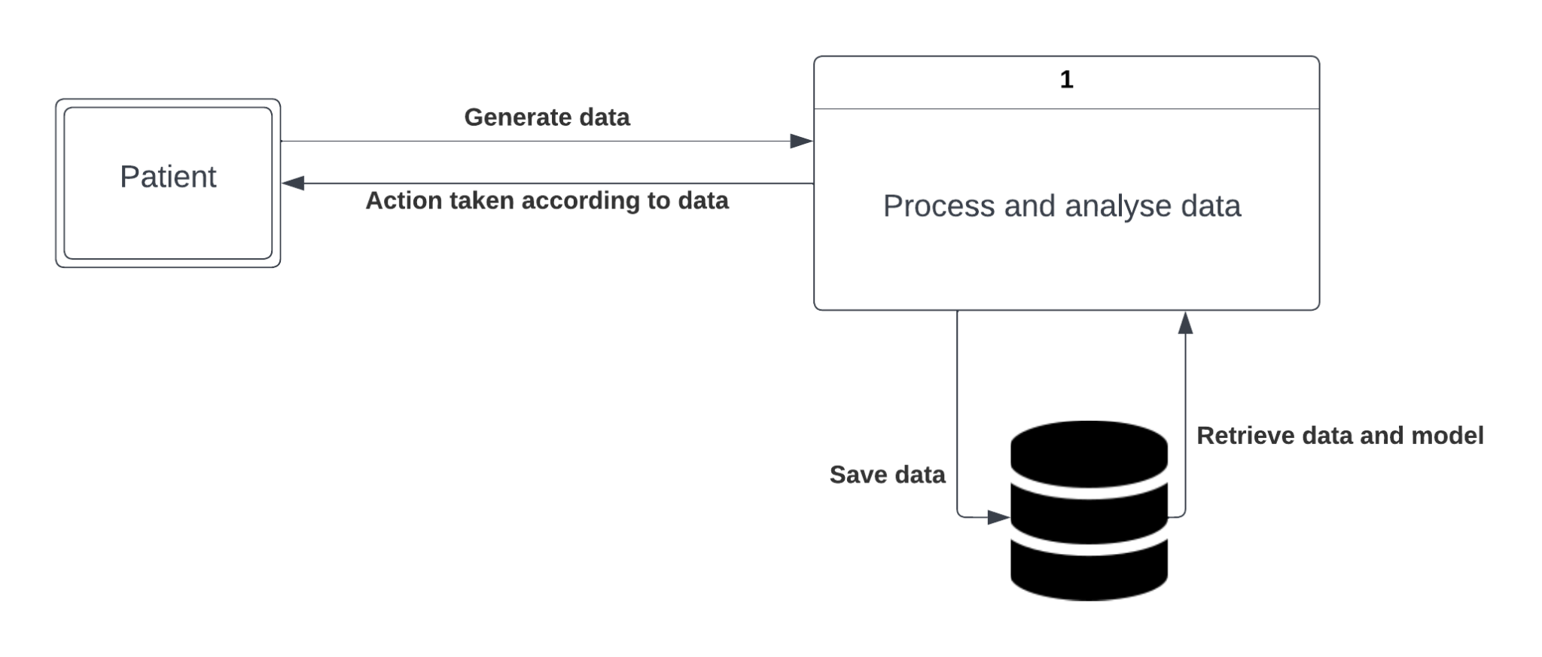

Fig 4.3 Architecture Design

In the L0 Data Flow Diagram (DFD), we see that the patient generates the data relating to their physical condition and pressure values. Then this data is processed and analyzed internally, from which the data is saved at the data store and retrieved from it when required. According to the analysis results, the actions taken by the system, affect the patient directly.

**4.2 Level 1 DFD**

The level 1 DFD for Voice recognition is as shown:

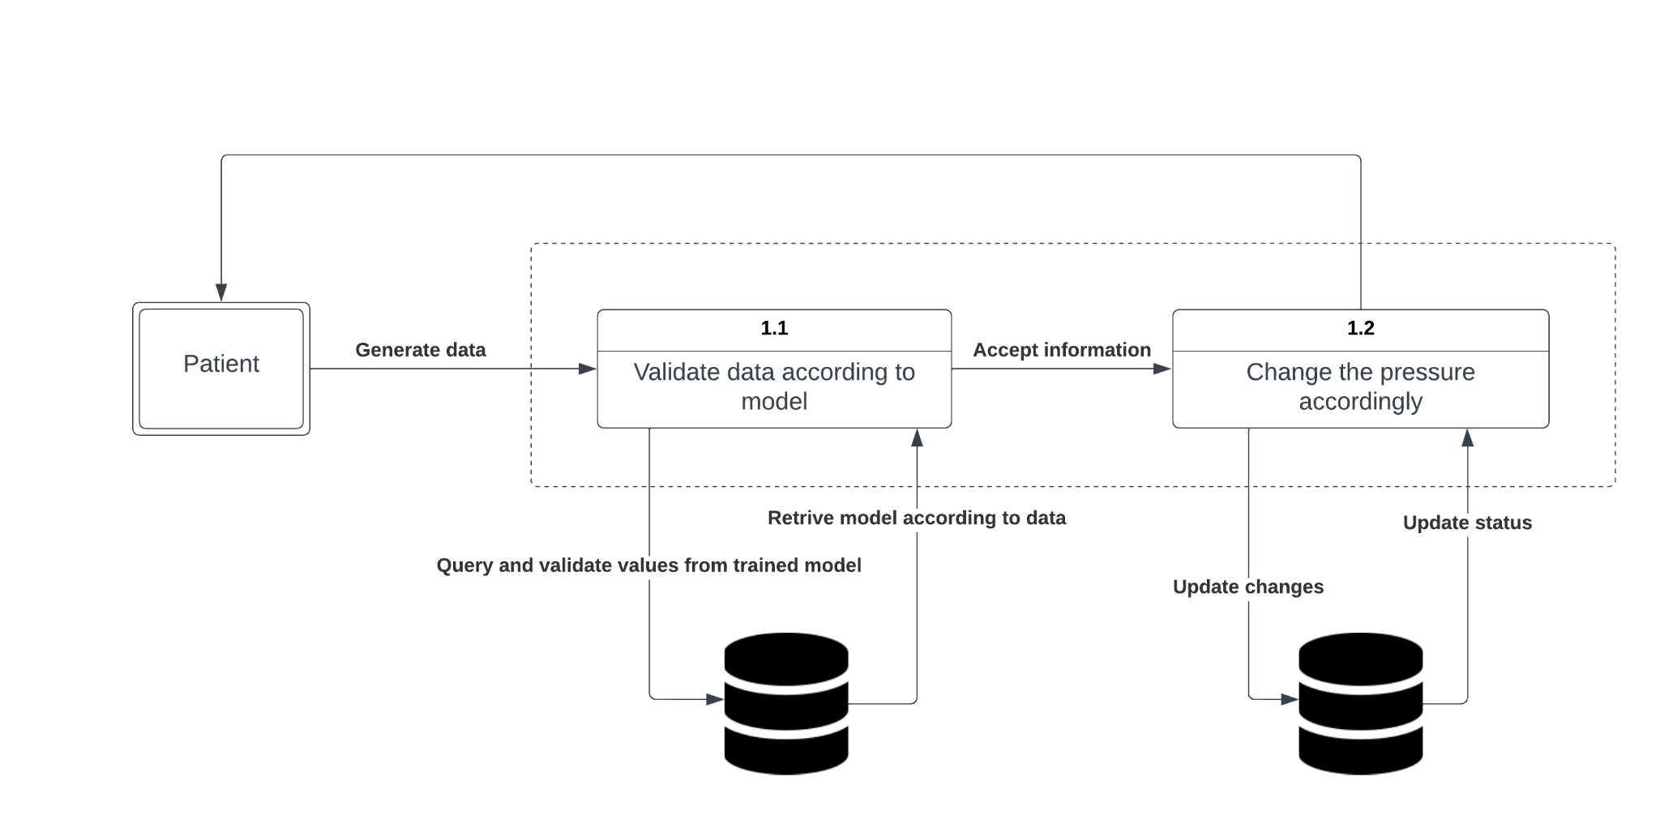

Fig 4.4 Level 1 DFD

In the L1 Data Flow Diagram (DFD), we see that the patient generates the data relating to their physical condition and pressure values. This data is validated with the model trained via the data stored in the data store. Based on the validation, necessary changes in pressure are made. The changes are reflected in the data store and are further used to retrain the model when required.

**4.3 Behavioral Diagram**

The Sequence diagram for the system is as follows:

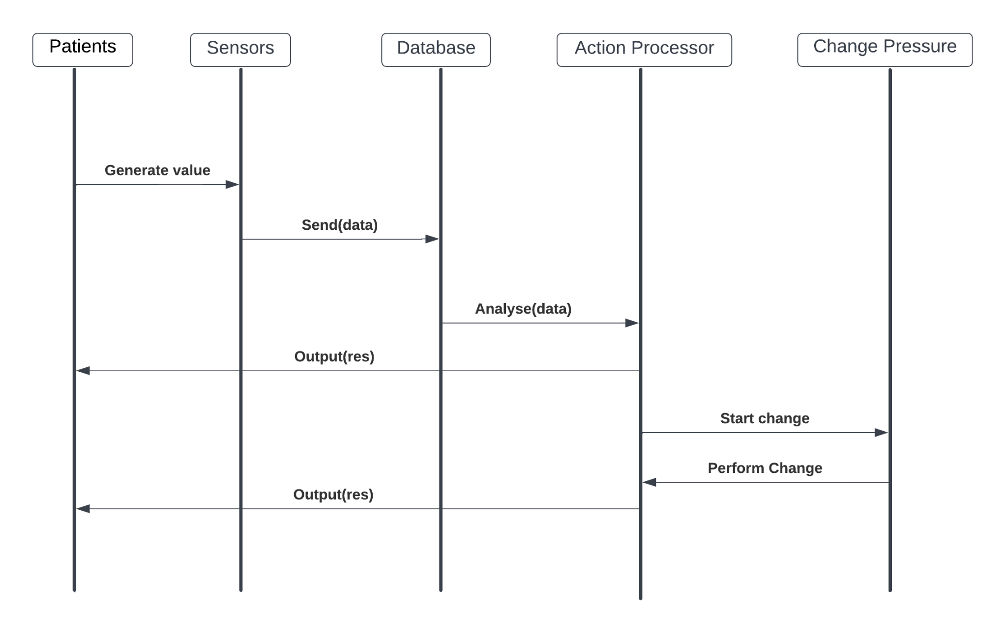

Fig 4.5 Behavioral Diagram

1. The patient generates values that are via the sensor
2. The data is sent to the data store/database
3. The action processor receives data from the data store and analyses it
4. The results of the analysis are sent to the client as a response
5. According to the analysis, with the help of the trained NN model, pressure in the at-risk areas is changed
6. After the change is performed, the result/output is sent to the patient/client

**Chapter 5**

**Implementation**

The solution we propose is divided into two parts: prevention and prediction. The prediction involves two factors: pressure and moisture. We propose monitoring the pressure values from the pressure sensor in real-time and comparing it against a set threshold value. If the threshold (400mm Hg) is crossed for a duration of time (4 to 6 hours), we take action that will be explained. For the moisture component, we measure the value via the moisture sensor and using the data and the trained model, we predict the formation of a DU.

The main goal of prevention is to reduce pressure and that can be done either by increasing the area of contact or decreasing the force on the body part. Moisture increases as the area of contact increases and so, the chances of a DU increase. We must consider moisture and pressure in preventing a DU.

**5.1 Programming Languages and Algorithms used**

The following languages have been used:

1. JavaScript for backend using NodeJS Runtime environment.
2. ExpressJS as a module for providing server-side functionality.
3. HTML as the markup language and Cascading Style Sheets (CSS) for styling the interface along with Embedded JavaScript (EJS).
4. Python for Arduino Programming as well as building the model.

The following algorithms have been used:

1. Representational State Transfer (REST) for creating API Endpoints connecting the server to the frontend, hardware, and model.
2. Neural Network implemented with the help of scikit-learn to predict the occurrence of Pressure Ulcers.

**5.2 Implementation of Modules of Project**

The project consists of the following modules:

1. Frontend Module
2. Server Module
3. Hardware Module
4. Prediction Module

**5.2.1 Frontend Module**

The frontend component of the system allows users to login to the system. It allows authorized users to add new patient information, view registered patient information, view the number of beds currently being monitored, view the number of patients and their information who are currently at risk, and also view historical data for every patient’s bed. It helps caretakers and doctors to take proactive and informed steps to prevent the formation of ulcers and also help improve the comfort of the patient.

The screens are styled with the help of Bootstrap and given functionality using the EJS Module provided by the NPM Package repository. It is hosted on Heroku for better accessibility. It is built to be responsive and lightweight, consuming the negligible amount of resources on the client side, thus making it accessible to all users using any kind of device.

**5.2.2 Server Module**

The backend of the system is the centralized server to which the frontend, the model, and the hardware components connect. No part of the system can directly connect to the database for security reasons, all queries to the database have to go through the server. It provides multiple API Endpoints for all the components.

The server is built using JavaScript as the primary language with a NodeJS runtime environment. It further uses ExpressJS to provide server functionality. It also uses modules like body-parser, dotnev, ejs, and mysql to be able to connect with the database. It is hosted on Heroku as well with automatic deployments enabled, thus making it fault-tolerant and highly responsive.

**5.2.3 Hardware Module**

All sensors are connected to Arduino Uno which is programmed using Python with the help of the Pyfirmata module. It connects to the server to send the values to the database. The different sensors used are as follows:

**Force Sensitive Resistor**

A force sensitive resistor (FSR) is a material which changes its resistance when a force or pressure is applied. Conductive film is an example of such force resistance material. In other words, force sensitive resistor it’s a sensor that allow you to detect physical pressure, squeezing and weight. Usually, force sensitive resistors are very simple to be made and low cost, although they are not accurate. For this reason, basically when you use FSR you should only expect to get ranges of response instead of precise results. Therefore, while FSRs can detect weight, they cannot detect exactly how many pounds of weight are on them. However, even not being extremely precise, for most touch-sensitive applications force sensitive resistors are a good cost vs. benefit deal.

FSR’s are usually composed by two substrate layers. Followed by the conductive film and the plastic spacer, which includes an opening aligned with the active area. After the spacer layer there’s the conductive print on substrate.

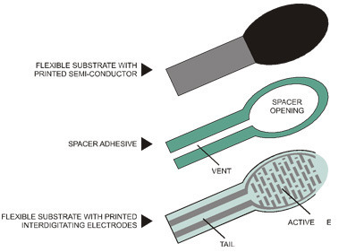

Fig 5.1 Working of FSR

When external force is applied to the sensor, the conductive film is deformed against the substrate. Air from the spacer opening is pushed through the air vent, and the conductive film comes into contact with the conductive print on the substrate. The more of the conductive ink area get in touch with the conductive film, the lower the resistance. Therefore, the more pressure applied on the sensor, the more the layers touch the conductive film and that makes the resistance go down.

**Temperature and Humidity Sensor**

Temperature and humidity sensors have two different ways of collecting data and measuring humidity and temperature. One type measures Relative Humidity (also known as RH) and the other type measures Absolute Humidity (also known as AH). They can also be categorized based on their size. Small sensors are used for smaller purposes and larger ones are usually used for industrial applications.

Some of these sensors are interfaced with a micro-controller for measuring the related data instantaneously. For example, the DHT11 temperature and humidity sensor is one of these digital temperature and humidity sensor with Arduino as its interface. It can also use other micro-controllers such as Raspberry Pi, etc.

These sensors have capacitive humidity sensing elements as well as a thermistor which is used to sense the environment’s temperature. There are two electrodes in the humidity sensing element (capacitor) and a moisture holding substrate works as a dielectric between these two electrodes. Whenever there is a change in the humidity levels, changes occur to the capacitance value accordingly. There’s an integrated IC in the unit that receives the measured data and processes the resistance values that have been changed due to the change in humidity, and converts the data into a digital form for the readers. So, this is how digital temperature and humidity sensors such as DHT11 measure humidity.

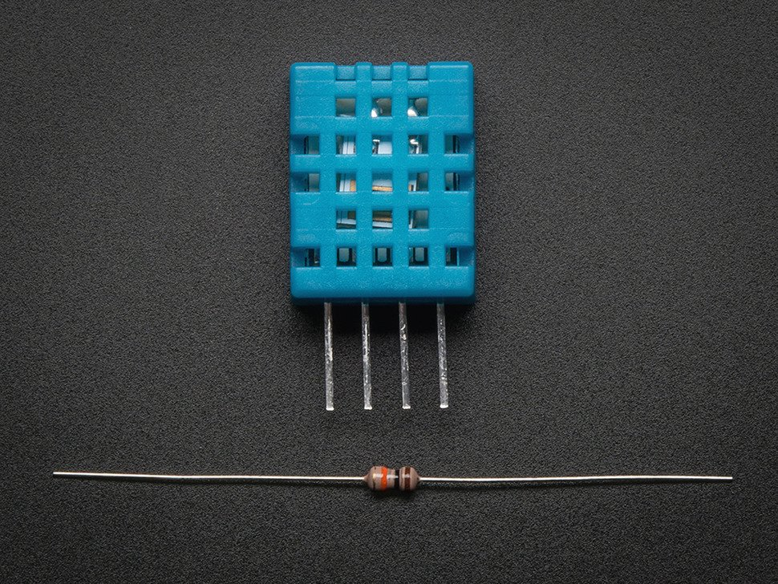

Fig 5.2 DHT11 Sensor

The easiest explanation would be that these sensors use a negative temperature coefficient thermistor for measuring temperature. When there’s an increase in the temperature of the environment, this element would cause a decrease in its resistance value.

Moreover, some temperature and humidity sensors with display have been designed which provide visual reporting of the humidity and the temperature and create a better experience for those using such sensors. Some of the newer temperature and humidity sensors with Wi-Fi have become popular these days as well that connects over Wi-Fi (or Bluetooth) enabling you to remotely monitor the humidity and the temperature of the place you’ve placed the sensor in with the help of an app that you can install on your phone. These sensors are great for when you are away and need to monitor the temperature and the humidity of the place. They have pretty good accuracy too.

**Arduino Uno**

The Arduino Uno is an open-source microcontroller board based on the Microchip ATmega328P microcontroller and developed by Arduino.cc. The board is equipped with sets of digital and analog input/output (I/O) pins that may be interfaced to various expansion boards (shields) and other circuits. The board has 14 digital I/O pins (six capable of PWM output), 6 analog I/O pins, and is programmable with the Arduino IDE (Integrated Development Environment), via a type B USB cable. It can be powered by the USB cable or by an external 9-volt battery, though it accepts voltages between 7 and 20 volts. It is similar to the Arduino Nano and Leonardo. The hardware reference design is distributed under a Creative Commons Attribution Share-Alike 2.5 license and is available on the Arduino website. Layout and production files for some versions of the hardware are also available.

The word "uno" means "one" in Italian and was chosen to mark the initial release of Arduino Software. The Uno board is the first in a series of USB-based Arduino boards; it and version 1.0 of the Arduino IDE were the reference versions of Arduino, which have now evolved to newer releases. The ATmega328 on the board comes preprogrammed with a bootloader that allows uploading new code to it without the use of an external hardware programmer.

While the Uno communicates using the original STK500 protocol, it differs from all preceding boards in that it does not use the FTDI USB-to-serial driver chip. Instead, it uses the Atmega16U2 (Atmega8U2 up to version R2) programmed as a USB-to-serial converter.

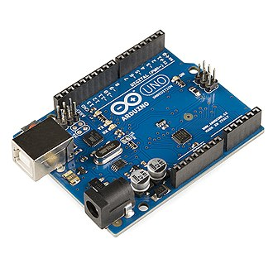

Fig 5.3 Arduino Uno

The Arduino/Genuino Uno has a number of facilities for communicating with a computer, another Arduino/Genuino board, or other microcontrollers. The ATmega328 provides UART TTL (5V) serial communication, which is available on digital pins 0 (RX) and 1 (TX). An ATmega16U2 on the board channels this serial communication over USB and appears as a virtual com port to software on the computer. The 16U2 firmware uses the standard USB COM drivers, and no external driver is needed. However, on Windows, a .inf file is required. Arduino Software (IDE) includes a serial monitor which allows simple textual data to be sent to and from the board. The RX and TX LEDs on the board will flash when data is being transmitted via the USB-to-serial chip and USB connection to the computer (but not for serial communication on pins 0 and 1). A SoftwareSerial library allows serial communication on any of Uno's digital pins.

**5.2.4 Prediciton Module**

The prediction module consists of a neural network for predicting the formation of ulcers using the sensor values. The network consists of one neuron for each sensor. In the hidden layer, the correlation between the sensor values is calculated, and based on the weights, the amount of contribution of each sensor is computed and the final layer produces a binary output of whether there is or there is not a chance for ulcer formation.

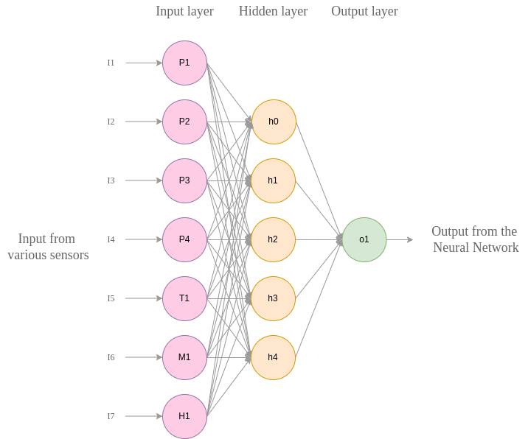

Fig 5.4 Neural Network Architecture. P1-P4: the inputs from pressure sensors, T1: temperature sensor value, M1: moisture sensor value, H1: humidity sensor value, h0-h4: hidden layer nodes, o1: output value

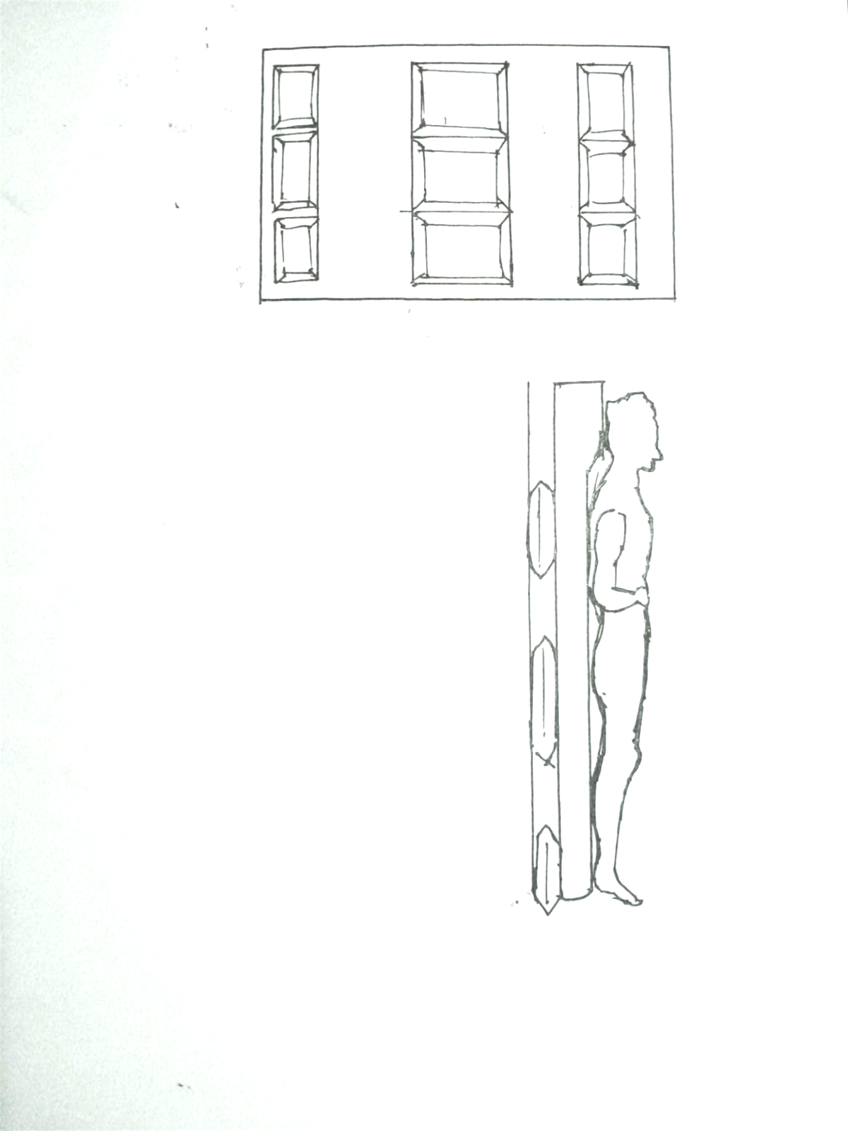

Fig 5.5 Bed Design

Our solution for prevention involves a mattress that is fabricated with air pockets situated evenly across the mattress. These air pockets can be inflated and deflated using a microcontroller and a portable air pump, based on the real-time pressure sensor readings. The air pockets have a layer of a cotton sheet over them, which is also connected to a pump to aerate humid areas and to make the mattress comfortable. the area of contact will have the air pockets deflated and the surrounding air pockets will be inflated. This will result in reduced pressure and increased aeration in the vulnerable area.

Body pressure distribution is constantly measured by the pressure sensors. Temperature and humidity are measured by using ambient temperature and humidity sensors. The inner pressure of each air cell is adjusted according to the site-specific body pressure data, temperature, and humidity. The pressure of the air cell is maintained by controlling the valves. The output valve is opened for a specified period to reduce the air pressure and the inlet valve is opened to increase the air pressure.

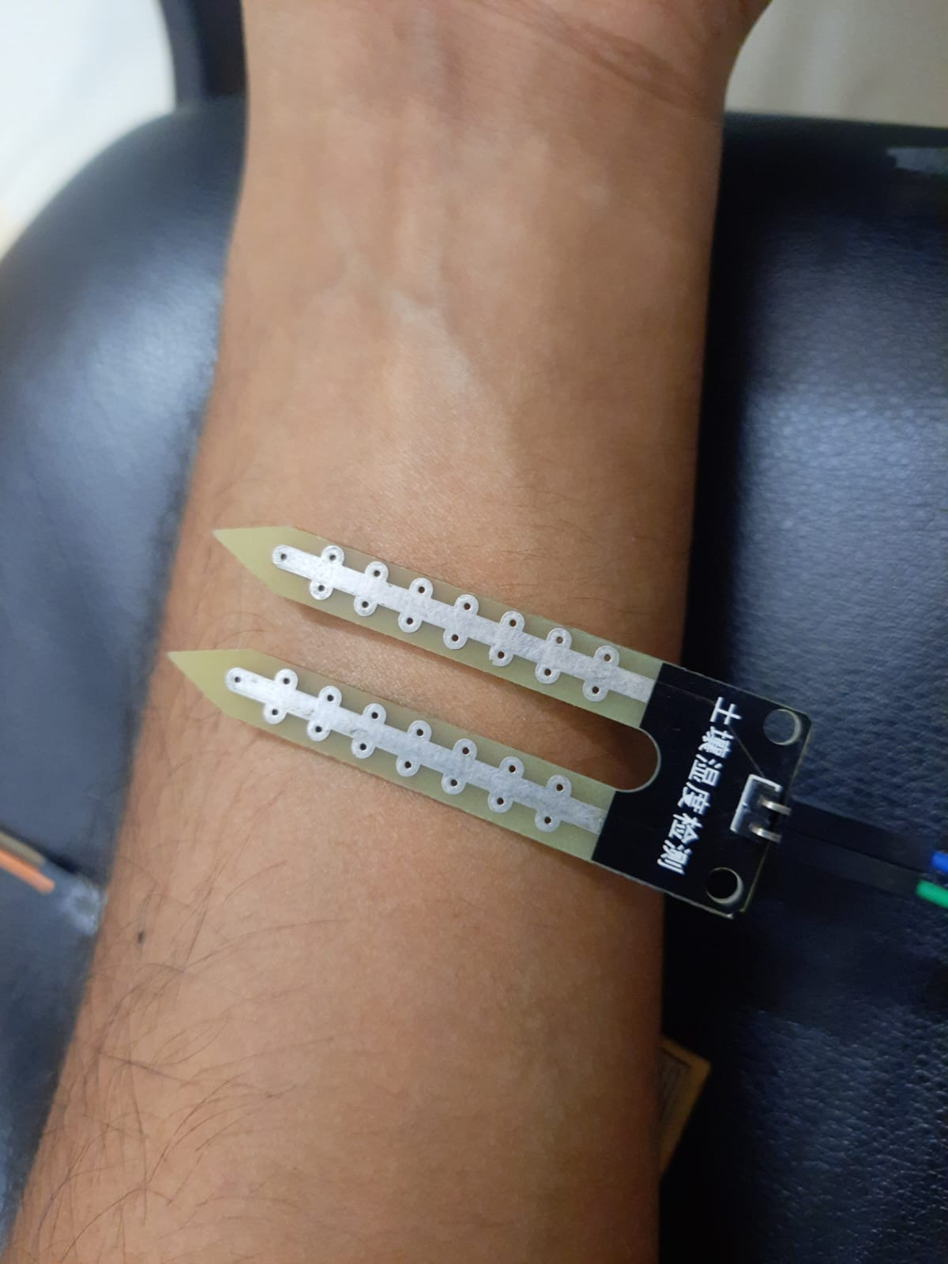 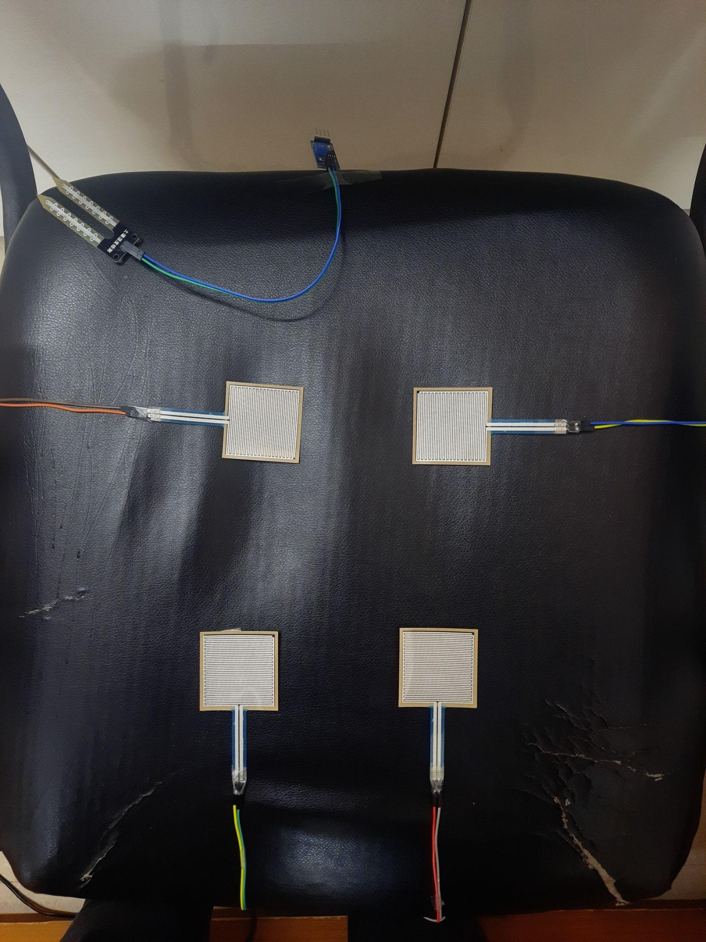

Fig 5.6 a) moisture sensor placed on the skin, b) the four pressure sensors placed on a seat

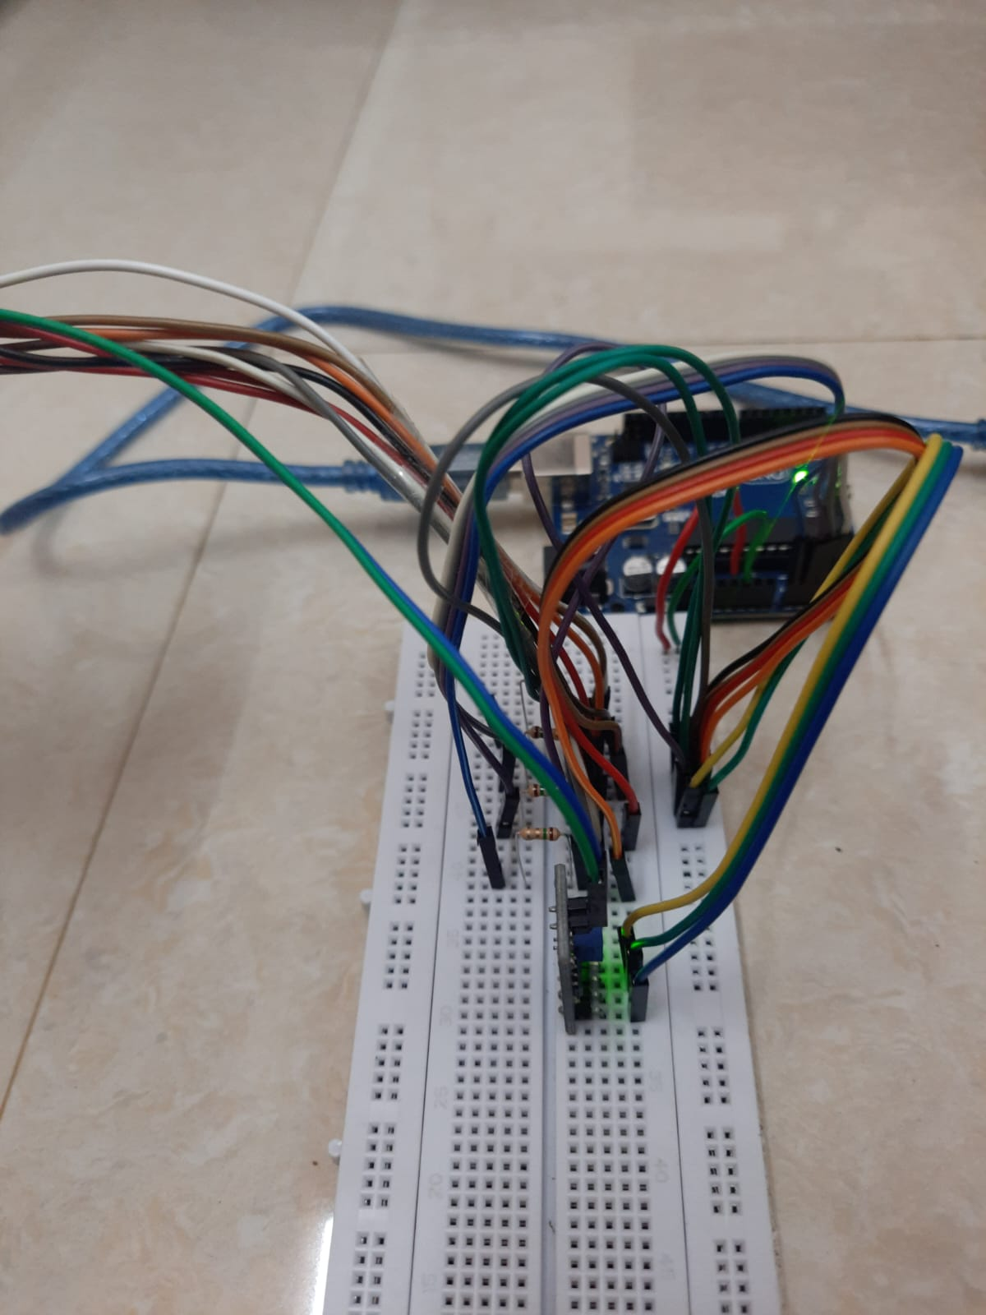 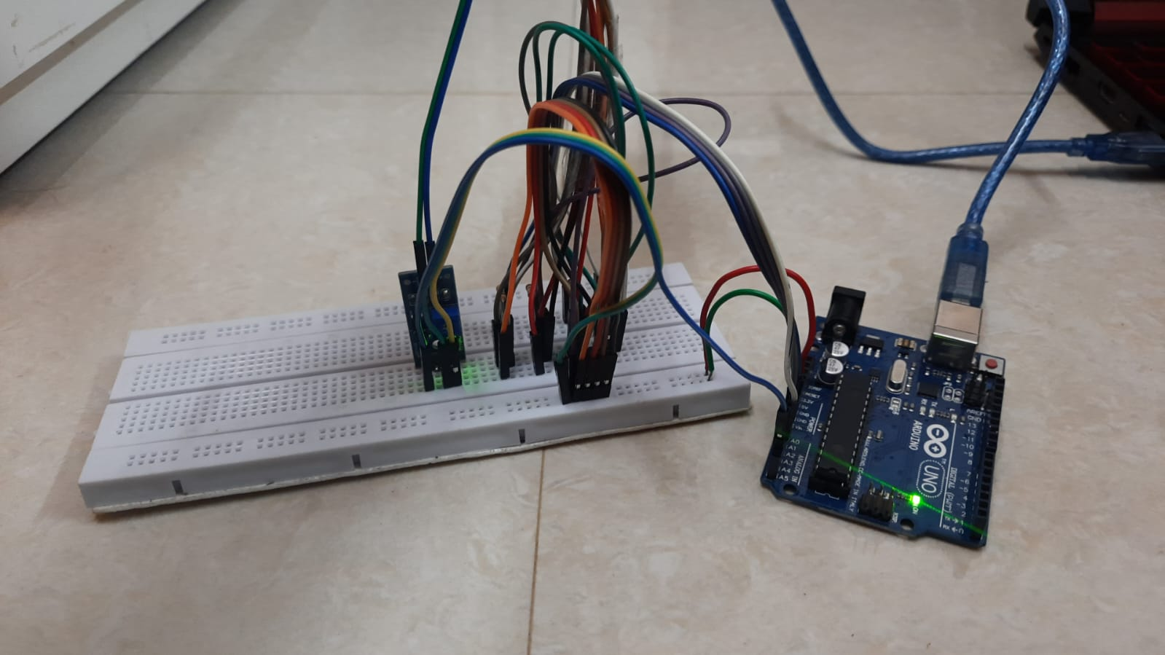

Fig 5.7 the circuit, seen on a breadboard, connected to an Arduino Uno and the various sensors

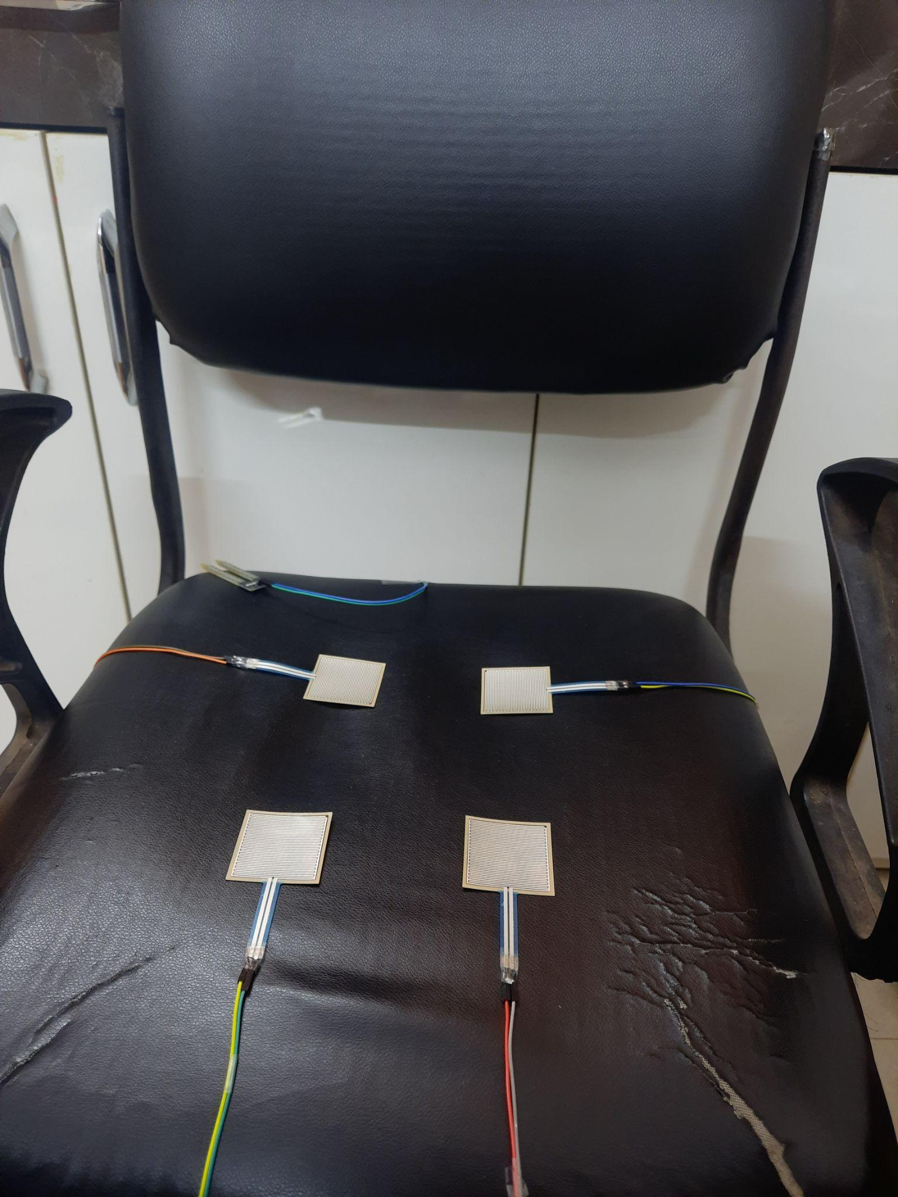 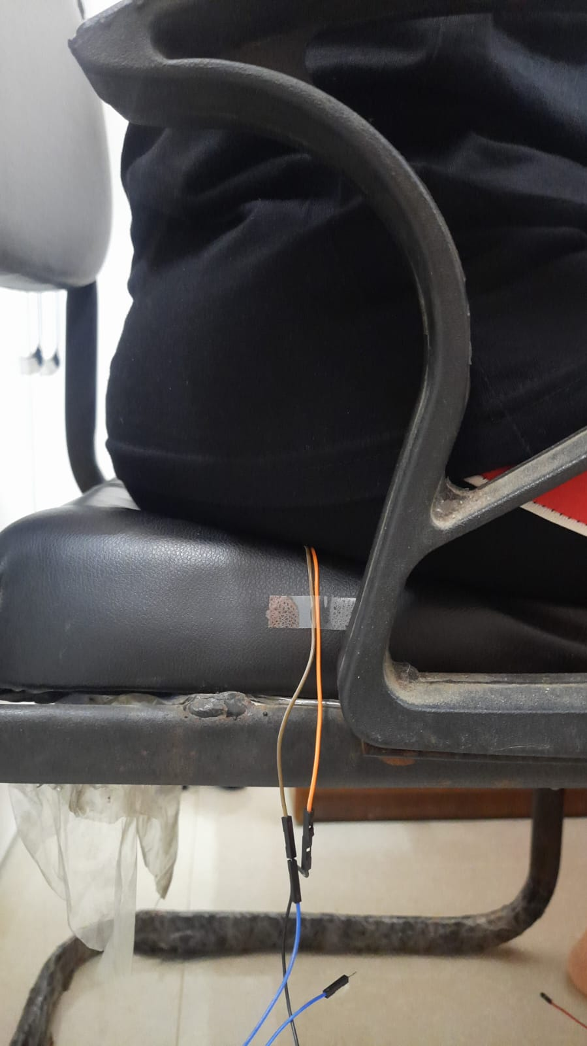 Fig 5.8 a) pressure sensors distributed across a seat, b) person sitting on the seat as the circuit reads the values from the sensors

**Chapter 6**

**Testing**

**6.1 Test Environment Description**

As the system is primarily focused on helping doctors and patients to prevent the formation of pressure ulcers during hospitalization, the test environment selected was a hospital bed or a wheelchair.

The assumptions made are that the hospital has sensors to monitor ambient temperature and moisture levels and that the sensors are placed according to the patient's physique. The issue of placing sensors at certain places can be solved by having an array of many connected sensors, which is, however, a future enhancement.

**6.2 Test Cases**

**6.2.1 Test cases for Front End Application**

| **Test Case** | **Test Steps** | **Expected Outcome** | **Test Results** |
| --- | --- | --- | --- |
| 1) Valid Login | Login with admin credentials | Display dashboard | Pass |
| 2) Invaid Login | Login with invalid credentials | Unauthorized access | Pass |
| 3) Timeout | Wait for 10 minutes without any activity | Automatically logs out the user | Pass |
| 4) Dashboard | Login and navigate to dashboard | See all patient information and current statistics | Pass |
| 5) Patient Information | Check patient information | Display selected patient’s information | Pass |
| 6) Patient History | Check sensor history | Display sensor values plotted on a graph | Pass |
| 7) Automatic Refresh | Wait on dashboard for 15 seconds | Webpage refreshes every 15 seconds | Pass |
| 8) Logout | Click the logout button | User is logged out | Pass |

**6.2.2 Test cases for Backend Server**

| **Test Case** | **Test Steps** | **Expected Outcome** | **Test Results** |
| --- | --- | --- | --- |
| 1) Endpoint for Login | POST request with valid credentials | Authenticate and authorize user to access the application | Pass |
| 2) Endpoint for viewing summary | GET Request | Send latest data | Pass |
| 3) Endpoint for viewing particular patient data | GET Request with patient ID as body in the request | Respond with the particular patient’s latest information | Pass |
| 4) Endpoint for viewing particular patient historical data | GET Request with patient ID as body in the request | Return array of all data related to the patient | Pass |
| 5) Endpoint for adding patient | POST Request with new patient details | Add data in database and return success | Pass |

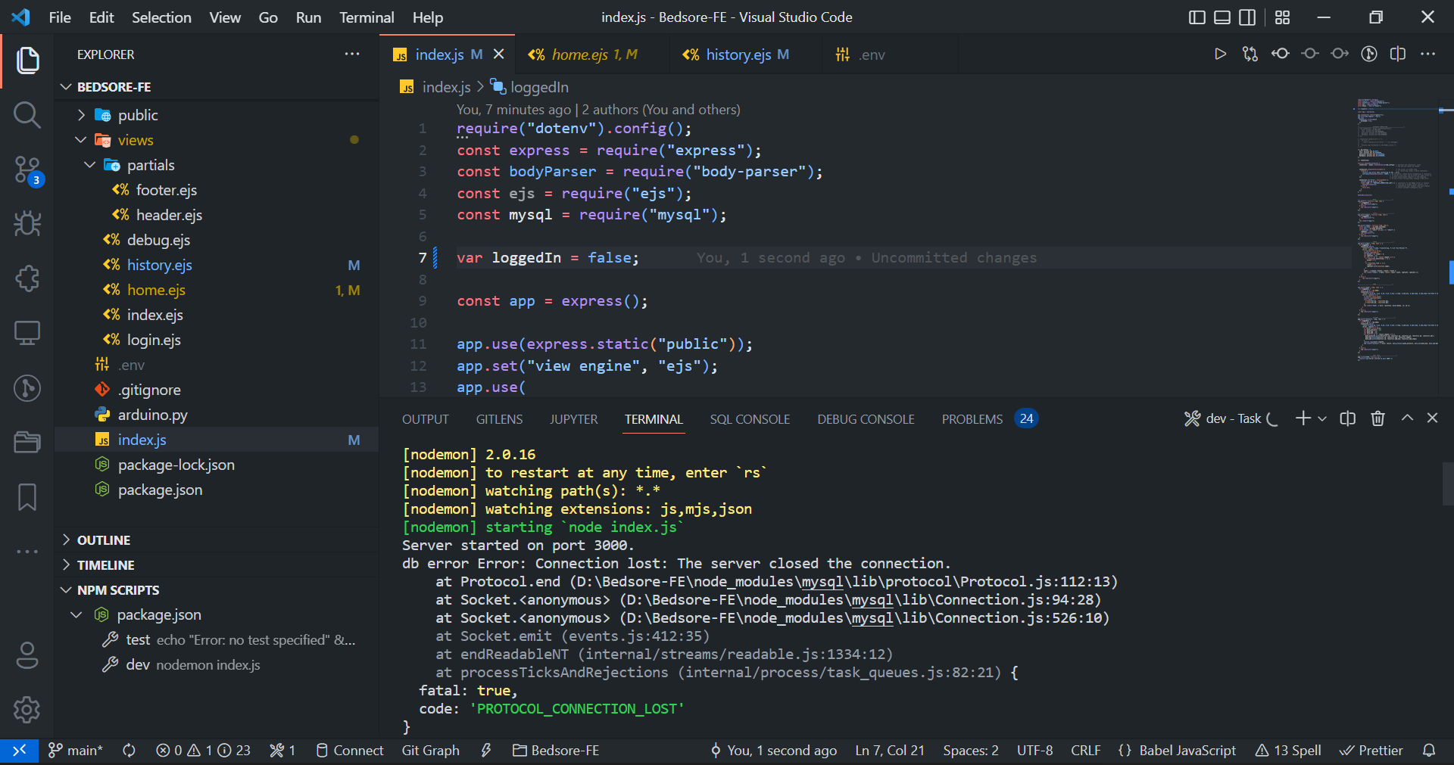

Fig 6.1 Connection to DB dropping frequently

The connection between the database (remote) and the code was frequently failing and needed to be restarted due to timeout. Connection to the MySQL server is usually lost due to either server restart, or a connection idle timeout (the wait_timeout server variable configures this). This was fixed using handlers. The connection had to be recreated since the previous one kept failing. We introduce a delay before attempting to reconnect, to avoid a hot loop, and to allow our node script to process asynchronous requests in the meantime.

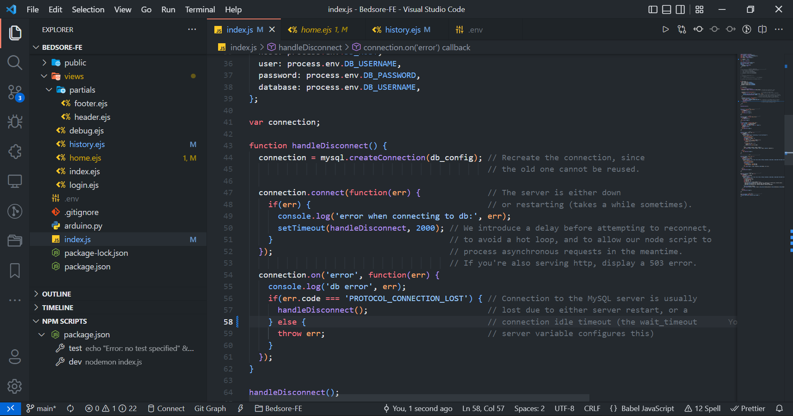

Fig 6.2 Fixed using handlers

**6.3 Testing the Neural Network Model**

The testing of the model is done using the test data set which is usually 20% of the original dataset. After the training is done and the model weights have been calculated, they are tested with the new data i.e. the test data. The accuracy of the test dataset is an overall estimate of the accuracy of the neural network model. The accuracy indexes can be seen in the result section.

**Chapter 7**

**Experimental Results**

1. **Login Screen** - The screen which allows users to enter the username and password to log in to the system. Unauthorized users are not allowed to access the system to prevent malicious users from tampering with confidential patient information.

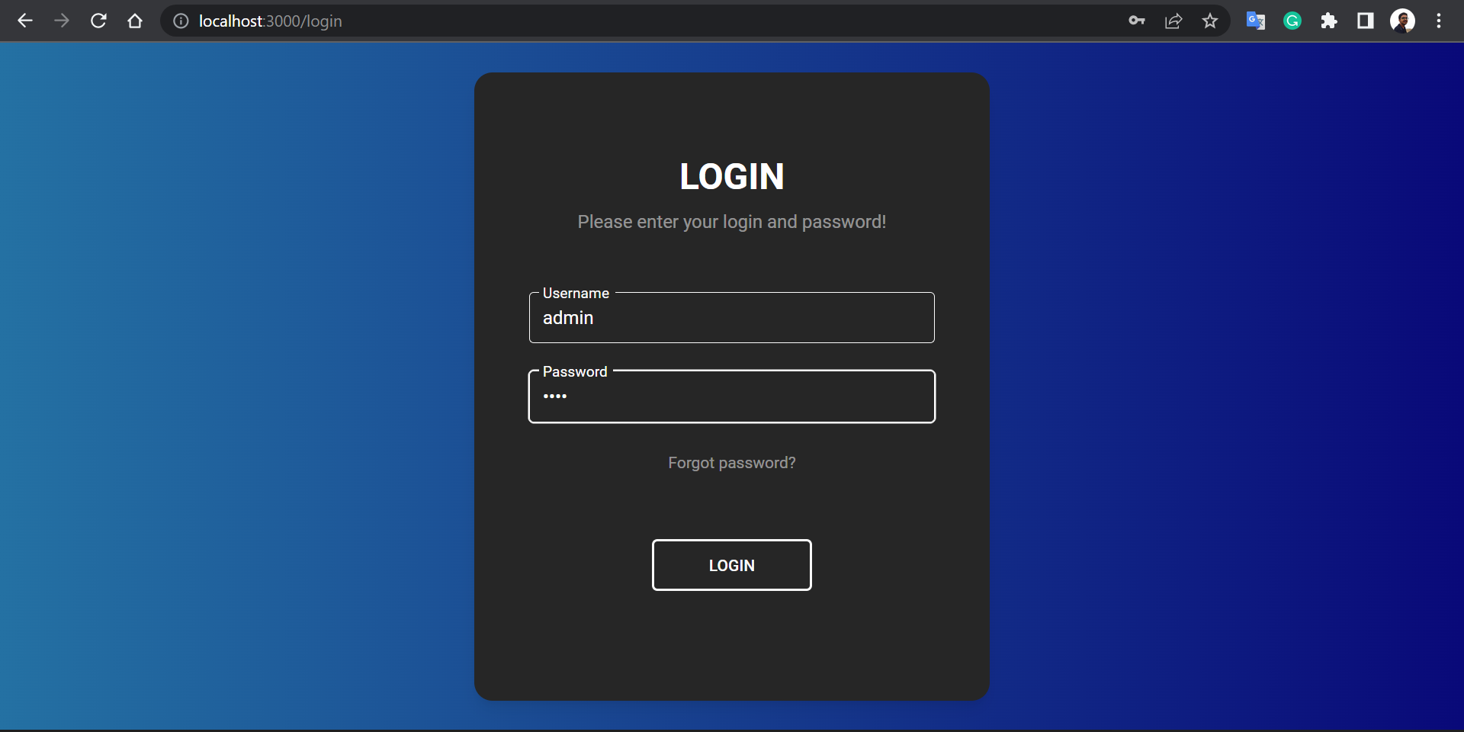

Fig 7.1 Login Screen

1. **Dashboard -** The screen allows authorized users to get a complete view of all the beds and patients in the hospital. It displays the number of patients currently being monitored, and the number of patients at risk, and also provides options to view patient information, and add new patients, and view selected patient’s current and past sensor values.

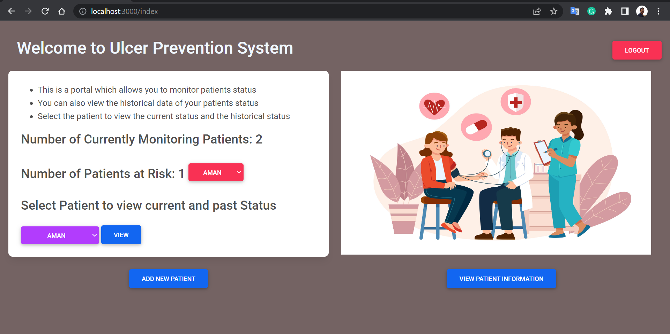

Fig 7.2 Dashboard

1. **Sensor Monitor** - This screen displays the current/last status of the selected patient and also displays the current status of the patient’s risk. The values are also plotted using a heatmap to improve viewer comfort. It also has the option to view the historical data of the patients in the form of graphs.

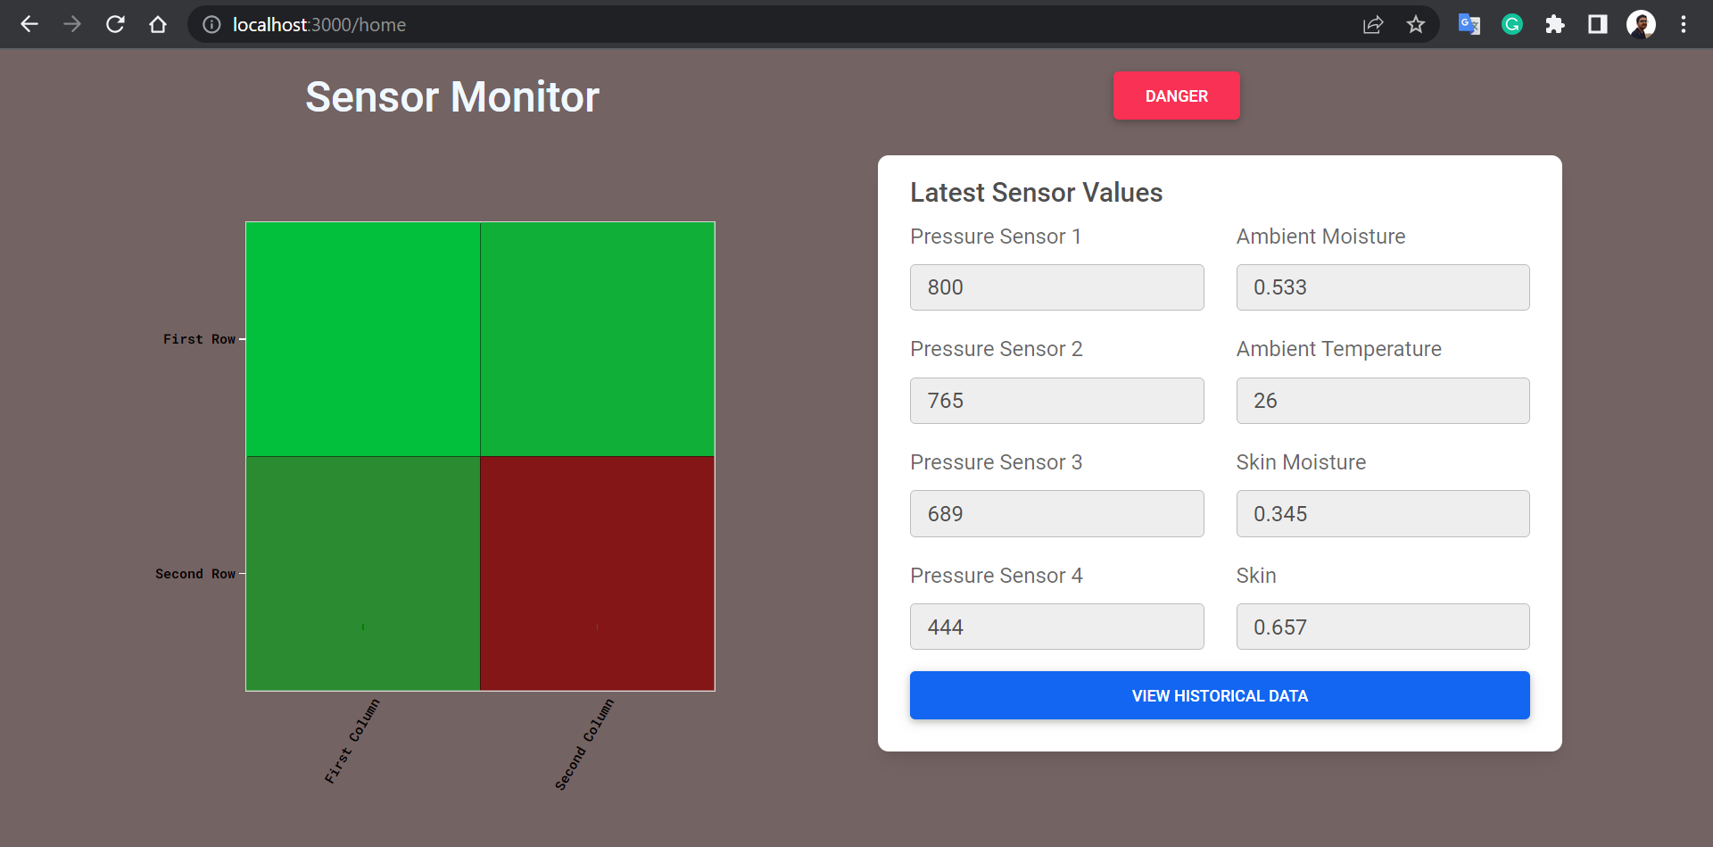

Fig 7.3 a) Sensor Monitor showing high-risk

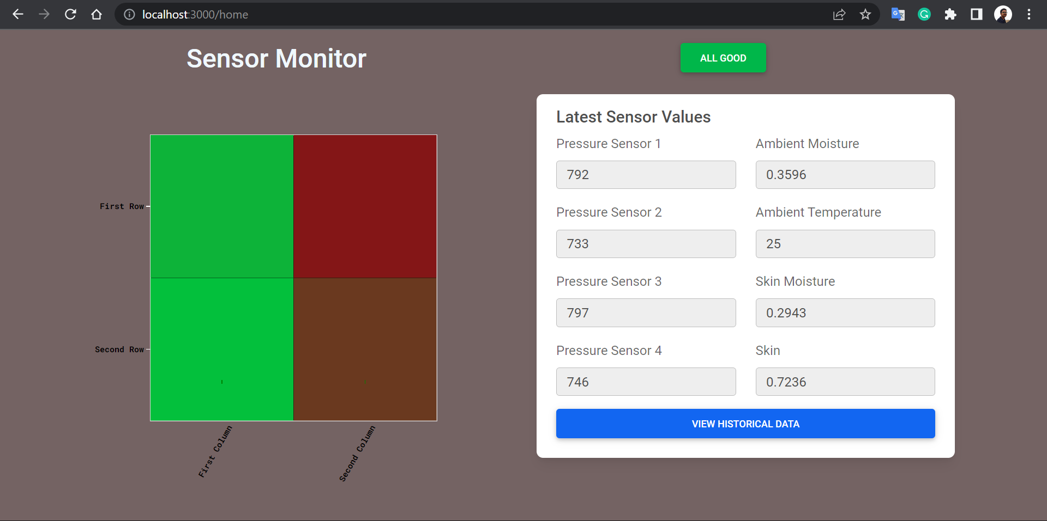

Fig 7.3 b) Sensor Monitor showing no risk

1. **Historical Data** - This screen shows the record of all sensor values as graphs to help the caretakers and doctors to know the past trends which can help them take better decisions.

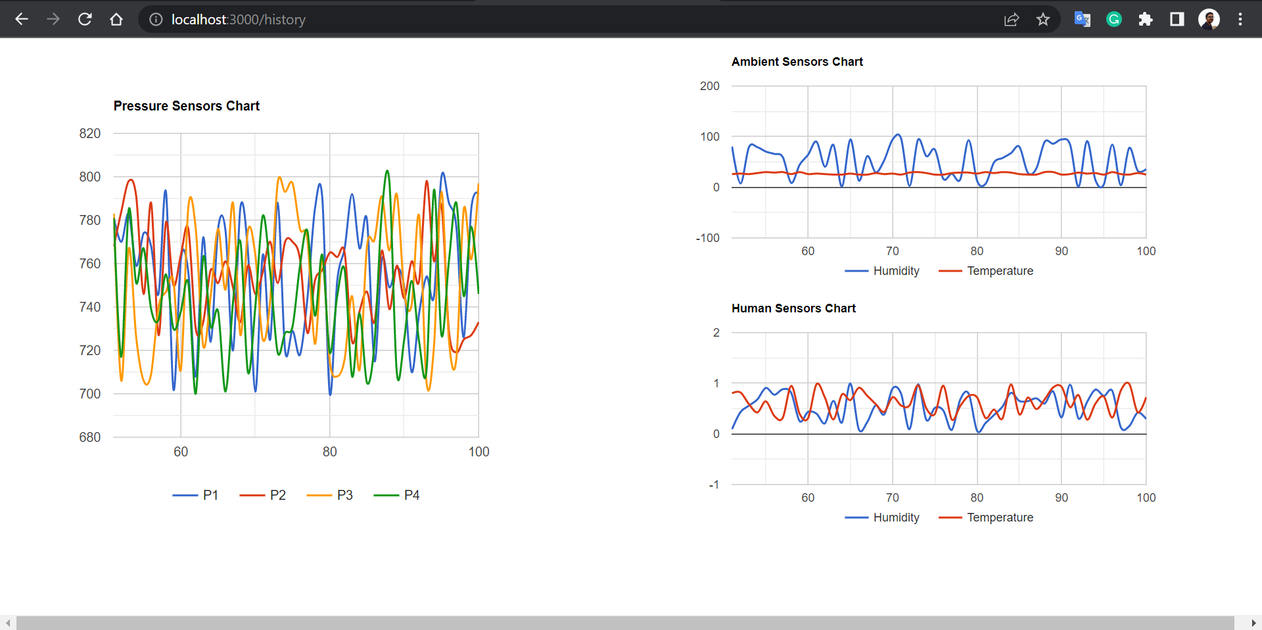

Fig 7.4 Historical Data

1. **Patient Information** - This screen shows detailed information about the patient.

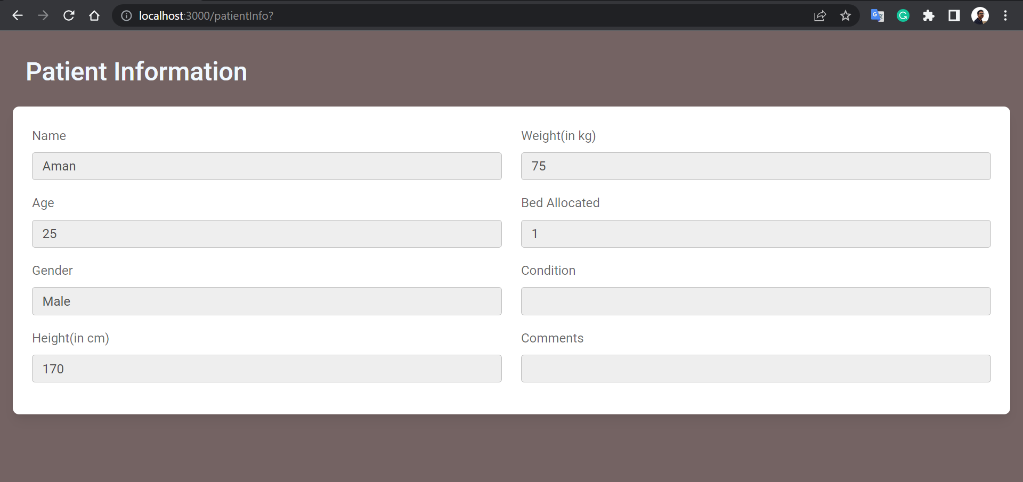

Fig 7.5 Patient Information

1. **Add Patient** - This screen allows authorized users to add new patient information and assign them beds as well. The patient’s name, age, gender, height, weight, condition, and comments can be recorded.

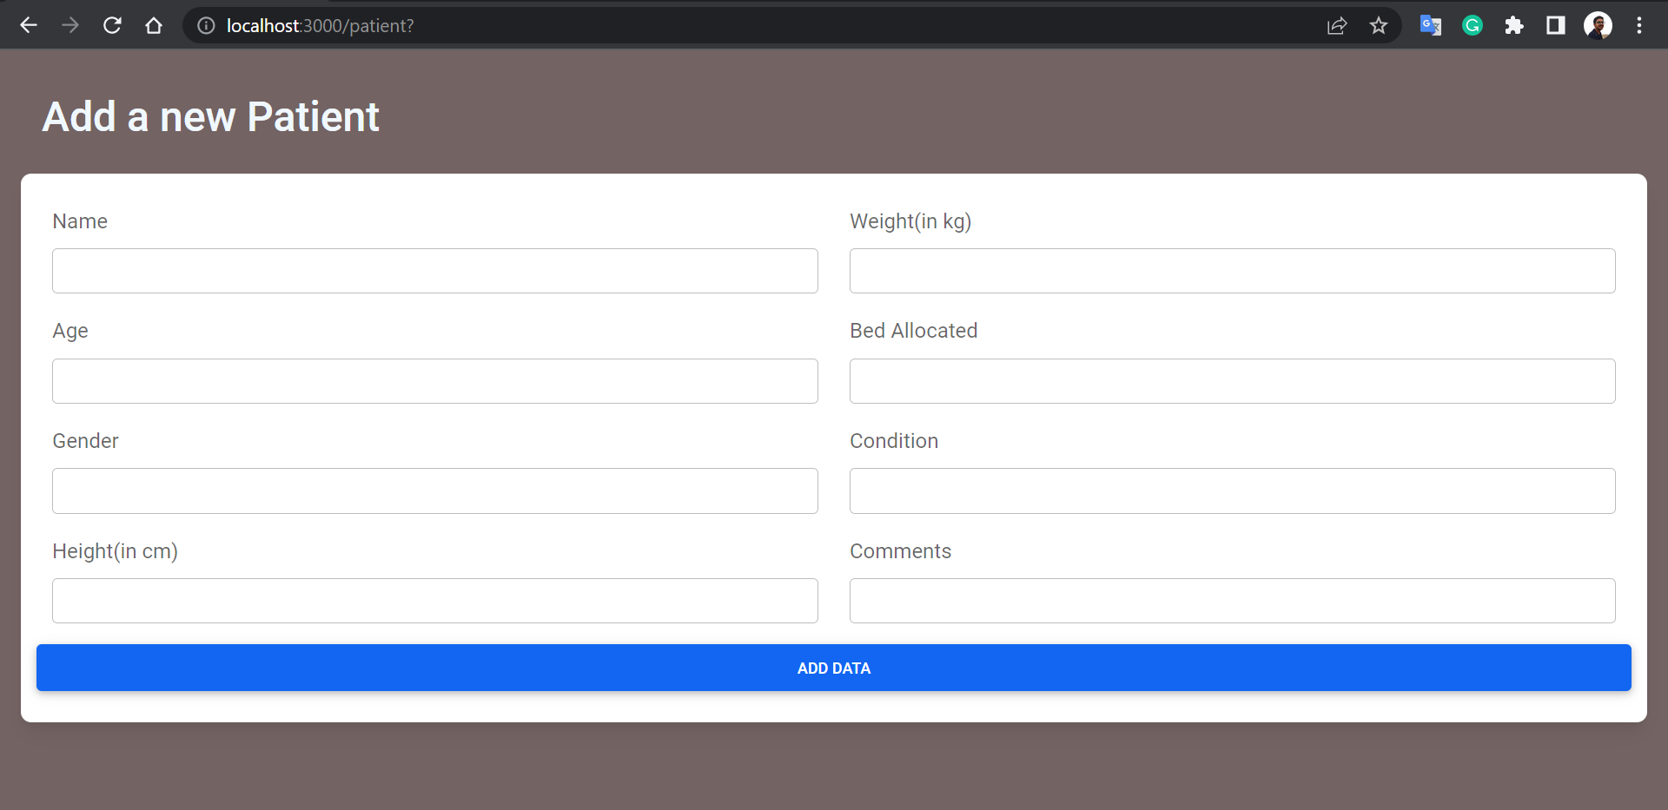

Fig 7.6 Add Patient Information

1. **Sensor Data** - The Patient’s data as stored in the database.

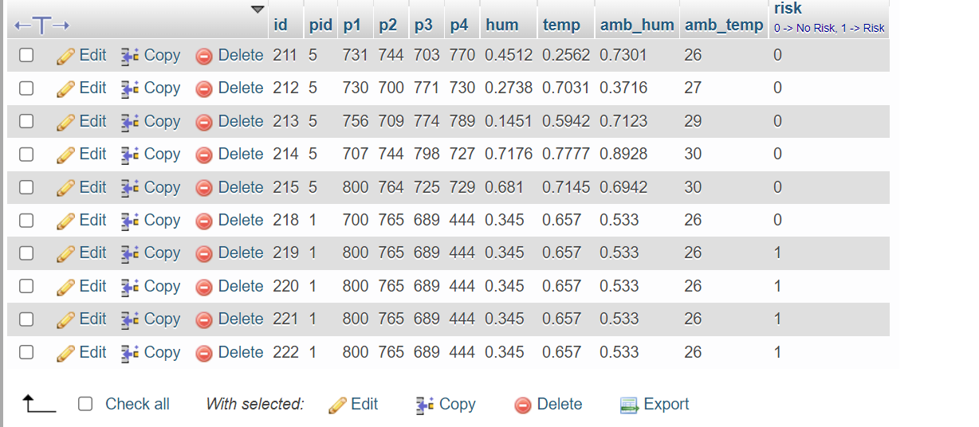

Fig 7.7 Sensor Data

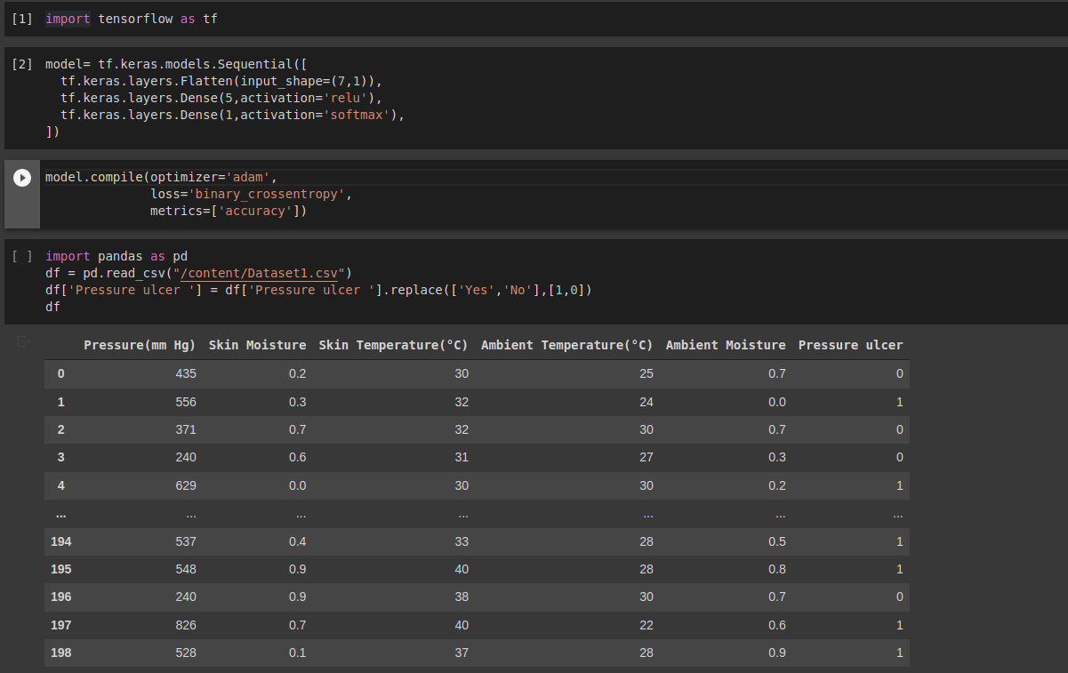

Fig 7.8 Training of neural network

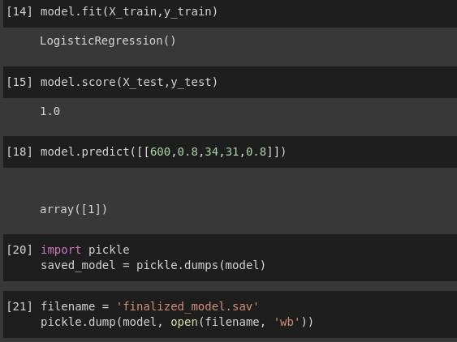

Fig 7.9 Output of neural network

| Activation Function | Training Accuracy | Testing Accuracy |
| --- | --- | --- |
| Binary Step Function | 82.6 | 78.3 |
| Linear Activation Function | 86.7 | 88.3 |
| Sigmoid Activation Function | 88.1 | 91.2 |
| ReLU Activation Function | 94.6 | 95.2 |

Table 7.1 Accuracy Indices

**Chapter 8**

**Conclusion**

This project was inspired by the fact that immobile patients/bedridden patients are having to heal from not only the original ailment, but also from bedsores. Our project will save a lot of effort that can be put to heal the person from their actual ailment. This could potentially cut down on hospital time, and by extension, the hospital bill.

The goal we aimed to achieve was to be able to detect and prevent the occurrence and formation of bedsores. We first had to research the causes and the factors that affect contracting bedsores. Then we extracted the essential features and developed a solution that monitored the features. Through this project, we were able to learn the importance of having mobility in our daily life, as long as we can. The impact of moisture and pressure in the formation of bedsores is formidable and must be regulated constantly for patients that have limited mobility or are bedridden.

As for the improvements that we plan on making to this project in the future, the biggest one that can be made would be to fabricate a mattress that would automatically redistribute the pressure, using pressure pumps, along with the circuit that we have already proposed.

In conclusion, by the monitoring pressure, moisture, and temperature of the bedridden patient and their surroundings over an amount of time, it can be decided whether they are at risk of developing bedsores with a high degree of accuracy.

**References**

[1] Bergstrom N, Braden BJ, Laguzza A, Holman V. The Braden Scale for Predicting Pressure Sore Risk. Nurs Res. 1987 Jul-Aug;36(4):205-10. PMID: 3299278.

[2] S. Mansfield, E. Vin and K. Obraczka, "An IoT System for Autonomous, Continuous, Real-Time Patient Monitoring and Its Application to Pressure Injury Management," 2021 IEEE International Conference on Digital Health (ICDH), 2021, pp. 91-102, doi: 10.1109/ICDH52753.2021.00021.

[3] Functional textiles for prevention of pressure ulcers

<https://www.emerald.com/insight/content/doi/10.1108/RJTA-10-2019-0047/full/html>

[4] B. Yilmaz, E. Atagün, F. Ö. Demırcan and İ. Yücedağ, "Classification of Pressure Ulcer Images with Logistic Regression," 2021 International Conference on INnovations in Intelligent SysTems and Applications (INISTA), 2021, pp. 1-6, doi: 10.1109/INISTA52262.2021.9548585.

[5] T. Daengsi, B. Muttisan, P. Wuttidittachotti and P. Sirawongphatsara, "Sustainable Development of a Prototype of Air Mattress from Re-Used Materials for Pressure Ulcer Prevention," 2021 International Conference on Green Energy, Computing and Sustainable Technology (GECOST), 2021, pp. 1-5, doi: 10.1109/GECOST52368.2021.9538773.

[6] M. Ehelagastenna, I. Sumanasekara, H. Wickramasinghe, I. D. Nissanka and G. K. Nandasiri, "Design of an Alternating Pressure Overlay for the Treatment of Pressure Ulcers," 2021 Moratuwa Engineering Research Conference (MERCon), 2021, pp. 202-207, doi: 10.1109/MERCon52712.2021.9525787.

[7] E. Elsharif, N. Drawil and S. Kanoun, "Automatic Posture and Limb Detection for Pressure Ulcer Risk Assessment," 2021 IEEE 1st International Maghreb Meeting of the Conference on Sciences and Techniques of Automatic Control and Computer Engineering MI-STA, 2021, pp. 142-149, doi: 10.1109/MI-STA52233.2021.9464360.

[8] Z. Shayan, M. Sabouri, M. Shayan, M. H. Asemani, A. Bina Sarmoori and M. Zare, "Pressure control of cellular electromechanical medical mattress for bedsore prevention," 2021 7th International Conference on Control, Instrumentation and Automation (ICCIA), 2021, pp. 1-7, doi: 10.1109/ICCIA52082.2021.9403585.

[9] E. -B. Park, J. -C. Heo, C. Kim, B. Kim, K. Yoon and J. -H. Lee, "Development of a Patch-Type Sensor for Skin Using Laser Irradiation Based on Tissue Impedance for Diagnosis and Treatment of Pressure Ulcer," in IEEE Access, vol. 9, pp. 6277-6285, 2021, doi: 10.1109/ACCESS.2020.3048242.

[10] Kottner, J., Cuddigan, J., Carville, K., Balzer, K., Berlowitz, D., Law, S., … Haesler, E. (2020). Pressure ulcer/injury classification today: An international perspective. Journal of Tissue Viability. doi:10.1016/j.jtv.2020.04.003.

[11] [Brecht Serraes](https://onlinelibrary.wiley.com/action/doSearch?ContribAuthorRaw=Serraes%2C+Brecht),[Martin van Leen](https://onlinelibrary.wiley.com/action/doSearch?ContribAuthorRaw=van+Leen%2C+Martin),[Jos Schols](https://onlinelibrary.wiley.com/action/doSearch?ContribAuthorRaw=Schols%2C+Jos),[Ann Van Hecke](https://onlinelibrary.wiley.com/action/doSearch?ContribAuthorRaw=van+Hecke%2C+Ann),[Sofie Verhaeghe](https://onlinelibrary.wiley.com/action/doSearch?ContribAuthorRaw=Verhaeghe%2C+Sofie),[Dimitri Beeckman](https://onlinelibrary.wiley.com/action/doSearch?ContribAuthorRaw=Beeckman%2C+Dimitri)(2018). Prevention of pressure ulcers with a static air support surface: A systematic review. [doi.org/10.1111/iwj.12870](https://doi.org/10.1111/iwj.12870).

[12] Dorner, Becky, Mary Ellen Posthauer, and David Thomas. "The role of nutrition in pressure ulcer prevention and treatment: National Pressure Ulcer Advisory Panel white paper." Advances in skin & wound care 22.5 (2019): 212-221.

[13] Šín, Petr, Alica Hokynková, Nováková Marie, Pokorná Andrea, Rostislav Krč, and Jan Podroužek. "Machine Learning-Based Pressure Ulcer Prediction in Modular Critical Care Data." Diagnostics 12, no. 4 (2022): 850.

[14] Perneger, Thomas V., Jean‐Michel Gaspoz, Anne‐Claire Raë, François Borst, and Céliane Héliot. "Contribution of individual items to the performance of the Norton pressure ulcer prediction scale." Journal of the American Geriatrics Society 46, no. 10 (1998): 1282-1286.

[15] Saleh, Zeena Sh, Auns Qusai Al-Neami, and Haider K. Raad. "Smart Monitoring Pad for Prediction of Pressure Ulcers with an Automatically Activated Integrated Electro-Therapy System." Designs 5, no. 3 (2021): 47.